SIMULATION FRAMEWORK FOR ZERO-CLICK ATTACKS
Final Report
Detection and Analysis of SMBGhost (CVE-2020-0796)
Daniel Gray
P2789044
BSc Cyber Security
De Montfort University
Supervisor: Debalina Padariya
Academic Year 2025-2026
Word Count: 9,493 words
(excluding acknowledgements, references and appendices)

Acknowledgements
I would like to take this opportunity to thank a few people who have assisted me during both my time at university and throughout this project in particular.

First of all I would like to thank my supervisors Muhammad Kazim and Debalina Padariya. Both of you have been an amazing help to me this year and I genuinely couldn’t have done it without either of you. Muhammad, without you this project would have never flourished as it has. Whilst it was frustrating to lose you as a supervisor due to your working constraints I am forever grateful to you for helping me get this project going. Debalina, you have been invaluable when it has come to all my submissions and your guidance whilst I was struggling with how to present my work and what to do next has been second to none. You picked up exactly where Muhammad left off and have help mould this project into what it is. Thank you for taking me in and assisting me thorough this year.

Secondly to Mum and Dad. I could fill this page with a thousand thank yous and it would still fall short. You are my best friends and inspiration. I cannot put into words how grateful I am to have such loving and supportive parents. You have seen me stress about the little things and beat myself up when things aren’t going my way and helped me to see the bigger picture. I wouldn’t have been able to do this without either of you. You’ve helped me to keep my head up and push myself to be the best version of myself. My experience at university is all thanks to you and I wouldn’t change a thing. I will always look back on my time at university fondly and that’s all down to the both of you. I cannot say it enough, but thank you.

Thirdly, to my brothers, Matthew, Benjamin, and the dog Eddie. To Eddie: “Woof, howl, woof, bark”. Mattie and Ben, as incredibly annoying as you both are, I am proud to call you my brothers. Thank you for the late night gaming moments and random check ins. Thank you for taking time to listen to my nonsense when I come home and forcing me to work hard, even if it was to prove a point that I’m the genius of the family.

Fourth, I would like to take this time to say thank you to the sanity checkers, my karting family. During my 3 years you guys have given me reason to take time for myself and connect with people in ways that I wouldn’t have imagined before coming to university. It’s thanks to you guys as a club that have helped me to come out of my shell and discover things about myself. Being your leader this year has been an absolute privilege.

Last of all, to my wonderful girlfriend Jazmine. Where do I begin. Our time together started at university and I can be sure that I come away from this experience having spent it as best as I can. You have given me so much not only in my confidence, but also helped me so much academically. Thank you for always pushing me to work that extra hour and proof reading each email or submission. Without you, not only would I have submitted many mistakes, but also would not have enjoyed my time at university nearly half as much as I have. Thank you for being you, I couldn’t imagine having spent this time with anyone else.

Abstract
Word count for this chapter: 361
Zero-click attacks represent a fundamental shift in cyber threat intelligence and is one of the most sophisticated and concerning forms of cyber exploitation, capable of compromising systems without any user interaction. Unlike traditional attack vectors that depend on human behaviour such as clicking malicious links or opening infected attachments, zero-click exploits target vulnerabilities in software components that automatically process incoming data, rendering conventional user-centric defences entirely ineffective.
This dissertation presents the design, implementation, and evaluation of a safe, reproducible simulation framework for studying zero-click attacks, with specific focus on SMBGhost (CVE-2020-0796), a critical integer overflow vulnerability in the SMBv3 protocol implementation present in Windows 10 versions 1903 and 1909. The framework employs synthetic, non-malicious payloads to replicate the network and system-level behavioural signatures of real zero-click exploitation without executing genuine malicious code, ensuring full compliance with ethical and legal requirements.
The simulation environment is built upon two isolated VMware virtual machines, one running the vulnerable Windows 10 1909 build and one running a fully patched Windows 10 22H2 build, enabling direct comparative analysis of system behaviour under identical test conditions. A multi-layered detection pipeline spanning network, system, and behavioural analysis layers was implemented to identify indicators of compromise at each stage of the simulated attack lifecycle. The project implements a comprehensive three-layer detection methodology encompassing network packet analysis, system-level behavioural monitoring via Sysmon telemetry, and statistical anomaly detection through baseline comparison.
During implementation, host operating system security controls prevented transmission of synthetically generated malformed SMB packets. This limitation revealed previously undocumented kernel-level SMB payload inspection mechanisms in modern Windows systems, which itself became a significant research finding. Despite this technical constraint, the research successfully developed multi-heuristic detection algorithms validated against documented CVE-2020-0796 specifications, analysed system-level configuration differences, and demonstrated a reproducible methodology suitable for academic research and cybersecurity education.
The multi-layered detection framework provides a foundation for future zero-click attack research while highlighting the practical challenges of conducting exploit simulation research on modern hardened operating systems. This work contributes to cybersecurity research by producing a reusable experimental platform to the academic community, addresses an identified gap in reproducible zero-click research, and offers practical insight into the detection of autonomous exploitation techniques.

Table of Contents
Contents
Acknowledgements 2
Abstract 4
Table of Contents 5
Glossary of Key Terms 8
1. Introduction 10
1.1 Project Overview 10
1.2 Aims and Objectives 11
1.3 Scope and Limitations 11
1.4 Problems with this research 11
1.5 Report Structure 12
2. Literature Review 13
2.1 Introduction 13
2.2 Evolution of Cyber Attack Models 13
2.3 Technical Foundations of Zero Click Attacks 13
2.4 Malware Associated with Zero Click Attacks 14
2.5 Stealth, Persistence, and Evasion 15
2.6 Case Studies in Zero Click Exploitation 15
2.7 Detection Challenges and Defensive Limitations 16
2.7.1 Inherent Detection Difficulties 16
2.7.2 Current Defensive Approaches and their limitations 16
2.8 Limitations of Existing Research 17
2.8.1 General gaps in existing research 17
2.8.2 Virtual Machine Based Simulation as a Research Gap 17
2.9 Research Gap and Project Justification 18
2.10 Summary 18
3. Methodology 20
3.1 Research Approach 20
3.2 Ethical Framework 20
3.3 The Synthetic Simulation Approach 21
3.4 Data Collection Strategy 21
3.5 Validity and Reliability 22
3.6 Baseline Data Collection 22
4. System Design and Architecture 23
4.1 Overall Architecture 23
4.2 Virtual Machine Configuration 24
4.2.1 Vulnerable System (VM1) 24
4.2.2 Patched System (VM2) 25
4.3 Network Architecture and Isolation 25
4.4 Multi-Layer Detection Pipeline 25
4.4.1 Network Layer 26
4.4.2 System Layer 26
4.4.3 Behavioural Layer (Analysis Engine) 26
4.5 Comparison Against Established IDS Tools 26
5. Implementation 28
5.1 Environment Setup and Configuration 28
5.1.1 Obtaining the Vulnerable ISO 28
5.1.2 Virtual Machine Deployment 28
5.2 Monitoring Tool Deployment 28
5.2.1 Sysmon Configuration 28
29
5.2.2 Wireshark and Network Capture 29
5.2.3 Python Analysis Environment 29
30
5.3 Baseline Data Collection 30
5.4 Synthetic Traffic Generation 32
5.5 Challenges Encountered 32
6. Results and Analysis 33
6.1 Baseline Data Comparison 33
6.2 System Configuration Comparison 34
6.3 Detection Algorithm Validation 34
6.4 Technical Discovery: Kernel-Level SMB Protection 35
7. Discussion and evaluation 37
7.1 Methodology Evaluation 37
7.2 Detection Framework Assessment 37
7.3 Limitations 37
7.4 Contributions of This Work 38
7.5 Critical Reflection and Future Directions 39
8. Conclusion 40
9. References 41
Appendices 43
Appendix A: Virtual Machine Configuration Specifications 43
Appendix B: Detection Algorithm Architecture 43
Appendix C: Sysmon Event Categories Monitored 44
Appendix D: Network Isolation Verification 44
Appendix E: Baseline Data Structure 44
Appendix F: Screenshots 45
Appendix G: Baseline Collection Script (baseline_collect.ps1) 48
Appendix H: Baseline Comparisons 49
Appendix I: Ethics Approval Documentation 50

Glossary of Key Terms
Word count for this chapter: 509 words
The following terms are used throughout this dissertation. Definitions are provided to ensure clarity for readers from varying technical backgrounds.

Term | Definition
ASLR | Address Space Layout Randomisation. A memory protection technique that randomises the location of key data areas in memory to complicate exploitation.
Baseband | The firmware layer in mobile devices that manages radio communications (cellular, Wi-Fi, Bluetooth). Operates independently of the main OS and can be a zero-click attack surface.
Buffer Overflow | A vulnerability where a program writes data beyond the boundaries of an allocated memory buffer, potentially allowing an attacker to overwrite adjacent memory and hijack execution.
CFI | Control Flow Integrity. A security mechanism that validates the targets of indirect control flow transfers to prevent exploitation through control flow hijacking.
CVE | Common Vulnerabilities and Exposures. A standardised naming scheme for publicly disclosed cybersecurity vulnerabilities, maintained by MITRE Corporation.
CVSS | Common Vulnerability Scoring System. A numerical score (0.0-10.0) representing the severity of a vulnerability. SMBGhost carries the maximum score of 10.0.
DEP/NX | Data Execution Prevention / No-Execute. A hardware and software feature that marks memory regions as non-executable, preventing code injection attacks.
Host-Only Network | A VMware virtual network mode that allows communication between VMs and the host machine only, with no routing to external networks.
IDS | Intrusion Detection System. A tool that monitors network or system activity for malicious behaviour or policy violations.
Integer Overflow | An arithmetic error that occurs when a calculation produces a value exceeding the maximum representable value for its data type, wrapping around to a small or negative number. Exploited by SMBGhost to cause an undersized memory allocation.
KB4551762 | The Microsoft security update that patches SMBGhost (CVE-2020-0796), released in March 2020.
PCAP | Packet Capture. A file format used to store captured network traffic, readable by tools such as Wireshark and Scapy.
RAT | Remote Access Trojan. Malware that provides an attacker with covert remote control over a compromised system.
Scapy | A Python library for crafting, sending, and analysing network packets, used in this project to generate synthetic SMBGhost simulation traffic.
SMB | Server Message Block. A network protocol used primarily for sharing files, printers, and other resources on Windows networks. SMBv3 is the version affected by SMBGhost.
SMBGhost | CVE-2020-0796. A critical integer overflow vulnerability in the Windows 10 SMBv3 compression handling mechanism (srv2.sys), enabling unauthenticated remote code execution.
srv2.sys | The Windows kernel driver responsible for SMBv3 protocol handling. The driver in which the SMBGhost vulnerability resides.
Sysmon | System Monitor. A Windows system service from Sysinternals that logs detailed system activity events to the Windows Event Log.
UAF | Use-After-Free. A memory corruption vulnerability that occurs when a program continues to use a pointer after the memory it references has been freed.
VM | Virtual Machine. A software-based emulation of a computer system running within a host machine, used in this project to provide isolated test environments.
Zero-Click Attack | A cyber attack that exploits a vulnerability without requiring any interaction from the target user, typically through automatically processed incoming data.
Zero-Day | A vulnerability unknown to the software vendor at the time of exploitation, for which no patch yet exists.

1. Introduction
Word count for this chapter: 917 words

1.1 Project Overview
The modern cybersecurity landscape has undergone a fundamental transformation. Whereas historically cyber attacks relied heavily on exploiting human behaviour such as phishing campaigns, social engineering, and malicious downloads, a growing class of attacks has emerged that eliminates the human interaction stage entirely. These are zero-click attacks: exploits that compromise systems automatically, without requiring any action from the victim.
The surge in zero-click attacks fundamentally challenges this model. These attacks exploit vulnerabilities in software components that automatically process incoming data without any user action. When a user receives an instant message, the messaging application automatically renders the content through image parsers and text processors. When a device receives network packets, the network stack automatically parses protocol headers. All of this occurs without user awareness or interaction. If vulnerabilities exist in these automatic processing mechanisms, attackers can achieve system compromise silently.
This project is focused on building a safe simulation environment to study zero-click attacks, with specific focus on SMBGhost (CVE-2020-0796). SMBGhost is a critical integer overflow vulnerability within the Windows SMBv3 compression handling mechanism, affecting Windows 10 versions 1903 and 1909. With a CVSS score of 10.0, the maximum possible severity, it represents one of the most significant vulnerabilities disclosed in recent years. It is network-based, requires no authentication, and requires no user interaction, an attacker can exploit it simply by sending a malformed packet to TCP port 445.
What makes zero-click attacks particularly dangerous is not just their technical severity but their fundamental challenge to conventional security thinking. Decades of security research and defensive investment have been directed at mitigating human-centric threats. User awareness training, phishing simulations, and behavioural defences form the bedrock of most organisational security programmes. Zero-click exploits render all of these irrelevant. As demonstrated by real-world deployments of Pegasus spyware, even technically sophisticated, security-aware users can be comprehensively compromised without any indication that an attack has occurred.
Despite the severity and growing prevalence of zero-click threats, academic research remains constrained. Ethical, legal, and practical barriers to reproducing real zero-click exploits in research settings are significant. Vendor patches often eliminate vulnerable code paths before systematic analysis can be conducted, and existing simulation platforms generally assume explicit attack triggers or user interaction. There is a clear and identified gap in the literature for reproducible, controlled experimental frameworks that can study zero-click attack behaviour without deploying genuine malicious code.
This project addresses that gap directly.

1.2 Aims and Objectives
The research aims to design, implement, and evaluate a reproducible framework for safe simulation and detection of zero-click attacks using controlled, synthetic approaches within an isolated virtual environment.
Specifically, the project seeks to:
- Conduct comprehensive literature review examining zero-click attack mechanisms, real-world case studies, technical foundations, and current detection limitations.
- Design and implement a virtualised simulation environment (VMware) using safe, synthetic payloads that replicate the network and system-level signatures of SMBGhost exploitation.
- Collect baseline and post-test data across from both a vulnerable and patched environment enabling comparative behavioural analysis.
- Implement a multi-layer detection framework and evaluate its ability to identify indicators of compromise within simulated attack traffic.
- Compare detection performance against established IDS tools, specifically Snort and Suricata.
- Critically evaluate the methodology, results, and implications, identifying areas for future research and development.

1.3 Scope and Limitations
This project focuses specifically on SMBGhost (CVE-2020-0796) as a representative zero-click vulnerability. The simulation uses synthetic, non-malicious payloads that replicate the structural characteristics of SMBGhost exploitation traffic without executing genuine exploit code. As a result, certain post-exploitation behaviours such as privilege escalation, lateral movement, and persistence mechanisms are modelled rather than directly observed. This is an intentional and necessary constraint arising from ethical requirements, and its implications for the generalisability of findings are discussed fully in Chapter 7.
The framework is scoped to Windows-based SMB exploitation. Mobile zero-click vectors (such as iMessage-based exploits like KISMET and FORCEDENTRY) and network stack vulnerabilities in embedded systems fall outside the scope of this project, though the detection methodology developed here has broader applicability that is discussed in the conclusion.

1.4 Problems with this research
Research into zero-click attacks faces significant barriers.
First, ethical and legal constraints prevent deployment of real exploits. Possession and distribution of functional zero-click exploits raises serious liability concerns under legislation including the Computer Misuse Act 1990.
Secondly, existing cybersecurity simulation platforms lack appropriate capabilities. Current testbeds assume explicit attack triggers or user interaction, unable to model autonomous exploitation occurring during background data processing.

Third, detection of zero-click attacks presents unique challenges. Traditional intrusion detection systems optimize for signature-based detection of known attacks or behavioural baselines assuming user-triggered events. Zero-click attacks often exhibit subtle behavioural changes that may be missed by conventional monitoring approaches.
Fourth, reproducible experimental research on zero-click attacks is limited. Much of the existing literature consists of post-incident forensic analyses describing exploitation after compromise. While valuable, these retrospective studies lack the controlled conditions necessary for systematic investigation and validation of defensive approaches.

1.5 Report Structure
Chapter 2 provides a comprehensive literature review covering the evolution of zero-click attack models, technical foundations, associated malware, real-world case studies, and the limitations of existing defensive approaches. Chapter 3 details the research methodology, including the ethical framework, simulation approach, and data collection strategy. Chapter 4 describes the system architecture and detection pipeline design. Chapter 5 covers the practical implementation of the simulation environment. Chapter 6 presents and analyses the experimental results. Chapter 7 discusses the findings in the context of the broader literature. Chapter 8 concludes the dissertation and suggests directions for future work.

2. Literature Review
Word count for this chapter: 2,442 words

2.1 Introduction
The increasing complexity of modern software ecosystems has contributed to an equalised evolution in cyber threats (Symantec, 2023). Historically, most cyber attacks required some degree of user interaction, such as clicking malicious links, opening infected attachments, or installing compromised software (Anderson, 2020). Consequently, much of the existing cybersecurity research and defensive tooling has focused on mitigating user driven threats, particularly phishing and social engineering attacks.
However, the emergence of zero click attacks represents a fundamental shift in this threat model. Zero click attacks exploit vulnerabilities in software components that automatically process data, allowing attackers to compromise systems without any user action (Bencsáth et al., 2011). Zero click exploits eliminate the human interaction stage entirely, shifting attacks from social dependency to pure technical exploitation (Prabith GS et al., 2023).
This literature review examines existing research on zero click attacks, including their technical foundations, associated malware, real world case studies, and defensive limitations. It further identifies a gap in experimental research and motivates the development of a virtual machine based simulation framework to study zero click attacks in a controlled and ethical environment.

2.2 Evolution of Cyber Attack Models
Traditional cyber attacks have largely relied on exploiting human behaviour. Phishing emails, malicious downloads, and social engineering techniques are examples of attack vectors that depend on user interaction to trigger malicious code execution (Hadnagy, 2018). As a result, security awareness training and endpoint protection mechanisms have been widely adopted as frontline defences.
Zero click attacks diverge from this model by eliminating the need for user involvement entirely. Instead, attackers exploit vulnerabilities in applications or operating system components that automatically parse untrusted inputs, such as messaging clients, email services, and multimedia libraries (Nisha and Kulkarni, 2022). This transition reflects a broader shift from human centric to vulnerability centric attacks.
High profile incidents, such as the deployment of Pegasus spyware, demonstrate that even security conscious users can be compromised without any observable action (Citizen Lab, 2021). These cases highlight the inadequacy of traditional threat models when applied to zero click attacks and underline the need for new defensive strategies. The rise of zero click exploitation has fundamentally challenged the premise that user education and awareness can serve as primary security controls.

2.3 Technical Foundations of Zero Click Attacks
Zero click attacks typically exploit vulnerabilities in software components that automatically handle incoming data. Common targets include SMS and MMS handlers, VoIP services, email preview engines, browser rendering engines, and media decoders (Chawla, 2021). These components are often complex and written in memory unsafe languages such as C and C++, increasing the likelihood of exploitable flaws, thus making them ideal attack surfaces.
Modern operating systems expose numerous zero click attack surfaces through background services. For example, iOS devices automatically process iMessage content through image rendering libraries (ImageIO), PDF parsers, and compression codecs before any user interaction (Groß, 2021). Similarly, Android devices parse incoming SMS messages, process Bluetooth packets, and handle Wi Fi frames without explicit user consent (Project Zero, 2020).
The literature identifies several vulnerabilities that frequent as enablers of zero click attacks:
Memory Corruption Vulnerabilities: Buffer overflows, heap overflows, use after free (UAF) errors, and integer overflows remain the most prevalent vulnerability types exploited in zero click attacks (Rahul et al., 2017). These flaws allow attackers to corrupt memory structures and hijack program control flow.
Logic Bugs: Type confusion vulnerabilities, deserialization flaws, and state machine errors can be exploited to achieve arbitrary code execution without traditional memory corruption (Molinyawe, 2022). These are particularly common in parsing complex file formats like PDFs, office documents, and image codecs.
Integer Overflows: Arithmetic errors in size calculations can lead to undersized buffer allocations, enabling subsequent buffer overflows during data processing (Miller et al., 2020).
In many cases, attackers leverage zero day vulnerabilities, which are unknown to vendors and lack available patches, allowing attacks to remain undetected for extended periods.
Importantly, zero click attacks do not require novel exploitation techniques rather, their impact arises from the automatic execution context in which vulnerabilities are triggered. This makes them particularly difficult to detect using conventional security tools, as the execution takes place during legitimate background processing.

2.4 Malware Associated with Zero Click Attacks
Zero click exploits often act as initial access vectors for deploying secondary malware. Research indicates that spyware, Remote Access Trojans (RATs), banking trojans, and surveillance malware are commonly delivered following successful zero click exploitation (SophosLabs Research Team, 2019).
RATs are particularly effective in this context, as they enable attackers to maintain persistent, covert control over compromised systems, facilitating data theft, keylogging, and remote surveillance (Rahul et al., 2017). Surveillance focused malware, such as Pegasus, further extends these capabilities by accessing microphones, cameras, location data, and encrypted communications (Marczak et al., 2021).
Financially motivated malware, including banking trojans and ransomware, has also been linked to zero click delivery mechanisms, particularly in mobile and enterprise environments (Nisha and Kulkarni, 2022). These findings suggest that zero click attacks function primarily as enablers, rather than standalone threats, amplifying the effectiveness of downstream malicious activities.

2.5 Stealth, Persistence, and Evasion
A defining feature of zero click attacks is their emphasis on stealth. Because exploitation occurs during legitimate background processes, victims often remain unaware of compromise until secondary effects become apparent (Chawla, 2021). To maintain persistence and evade detection, attackers employ techniques such as encrypted command and control channels, delayed execution, fileless malware, and polymorphic payloads (SophosLabs Research Team, 2019).
Signature based antivirus solutions are particularly ineffective against these attacks, as zero click exploits frequently rely on previously unknown vulnerabilities and rapidly changing payloads (Bencsáth et al., 2011). As a result, detection often occurs post compromise through anomaly detection or forensic analysis rather than real time prevention.
These characteristics highlight the importance of studying zero click attacks as long lived, low visibility processes, rather than immediate intrusion events.

2.6 Case Studies in Zero Click Exploitation
Several real world case studies illustrate the impact and sophistication of zero click attacks. Pegasus spyware, developed by NSO Group, has been widely documented for its use of zero click exploits to compromise mobile devices globally, targeting journalists, activists, and government officials (Citizen Lab, 2021). Its ability to bypass encryption and persist across updates underlines the severity of the threat.
Recent zero-click exploits demonstrate the continued sophistication and effectiveness of these attack vectors against modern mobile platforms.
KISMET (2020): Discovered by Citizen Lab, this iMessage zero-click exploit leveraged a vulnerability in Apple's image processing library (ImageIO) to achieve remote code execution through a maliciously crafted GIF file sent via iMessage (Marczak et al., 2020). The exploit chain involved heap manipulation techniques and successfully bypassed multiple iOS security features including Pointer Authentication Codes (PAC). KISMET was deployed against journalists and activists, demonstrating the targeting precision of zero-click spyware campaigns.
FORCEDENTRY (2021): This sophisticated zero-click exploit, also targeting iMessage, utilized a vulnerability in Apple's image rendering library for processing malformed PDF files (Citizen Lab, 2021). The exploit leveraged an integer overflow in the JBIG2 decoder component, allowing arbitrary code execution without user interaction. FORCEDENTRY's discovery highlighted that even after Apple implemented additional security measures like BlastDoor, determined attackers continued to find novel exploitation paths. The exploit was linked to NSO Group's Pegasus spyware and affected devices running iOS 14.8 and earlier versions.
Android Baseband Vulnerabilities (2023): Google's Project Zero team disclosed multiple critical zero-click vulnerabilities in Samsung's Exynos modems affecting millions of Android devices (Project Zero, 2023). These vulnerabilities could be triggered remotely via malformed cellular network packets without any user interaction, potentially enabling remote code execution at the baseband processor level. The discovery emphasized that zero-click attack surfaces extend beyond application-layer protocols to fundamental network stack components.
Stuxnet, although not a pure zero click attack, demonstrated the strategic use of zero day vulnerabilities to achieve autonomous propagation and physical sabotage, marking a turning point in state sponsored cyber warfare (Langner, 2011). Its use of multiple zero days and sophisticated evasion techniques set a precedent for nation state operations. Other malware families, such as Emotet and DarkTequila, highlight how stealth, polymorphism, and persistence can be combined to evade detection and enable large scale campaigns (ESET, 2019).
These case studies collectively demonstrate that zero click exploitation is not theoretical but an established and effective attack strategy, being deployed by both commercial vendors and nation state actors.

2.7 Detection Challenges and Defensive Limitations

2.7.1 Inherent Detection Difficulties
Traditional security controls face fundamental challenges when defending against zero click attacks:
Lack of User Visible Indicators: Unlike phishing or social engineering attacks, zero click exploitation provides no opportunity for user intervention or recognition of suspicious behaviour (Marczak et al., 2021).
Exploitation During Legitimate Operations: Because vulnerable code executes as part of normal system functionality (message processing, network stack operations), distinguishing malicious from benign activity becomes exceptionally difficult (Groß, 2021).
Zero Day Dependency: Many zero click attacks rely on previously unknown vulnerabilities, rendering signature based and rule based detection ineffective until after the vulnerability becomes public (Bilge & Dumitras, 2012).
Evasion of Sandboxing: Modern exploits employ anti analysis techniques to detect and evade sandbox environments, including timing attacks, hardware checks, and environment fingerprinting (Balzarotti et al., 2010).

2.7.2 Current Defensive Approaches and their limitations
Memory Safety Mitigations: Modern operating systems implement multiple memory protection mechanisms
ASLR (Address Space Layout Randomization): Randomizes memory addresses to complicate exploitation
DEP/NX (Data Execution Prevention): Marks memory pages as non executable
Stack Canaries: Detects stack buffer overflows
Control Flow Integrity (CFI): Validates indirect control flow transfers (Abadi et al., 2009)
However, these mitigations are frequently bypassed in sophisticated zero click exploits through information leaks, partial overwrites, and carefully crafted exploitation primitives.
Sandboxing and Compartmentalization: Apple’s BlastDoor service, introduced in iOS 14, demonstrates the industry response to zero click iMessage exploits (Groß, 2021). BlastDoor processes untrusted iMessage content in a heavily sandboxed environment with minimal system privileges, limiting the impact of successful exploitation.
Behavioral and Anomaly Detection: Machine learning based approaches attempt to identify anomalous system behavior indicative of exploitation (Buczak & Guven, 2016). However, these systems suffer from high false positive rates and can be evaded through careful mimicry of legitimate behavior.
Despite these protective measures, zero click attacks continue to succeed due to:
Implementation Complexity: Modern systems contain millions of lines of code with inevitable vulnerabilities
Backwards Compatibility: Legacy protocols and file formats cannot easily incorporate modern security features
Performance Constraints: Comprehensive memory safety checks impose unacceptable performance penalties in real time processing scenarios
Update Latency: Even after patches are released, device update rates remain low, particularly in enterprise and embedded systems
The continued success of zero click exploitation campaigns demonstrates that current defensive strategies, while valuable, remain insufficient against well resourced adversaries.

2.8 Limitations of Existing Research

2.8.1 General gaps in existing research
Despite growing recognition of zero click threats, much of the existing literature remains descriptive or retrospective. Ethical, legal, and practical constraints limit the ability of researchers to reproduce real world zero click exploits, particularly those involving zero day vulnerabilities. Zero click exploits targeting specific software versions in particular configurations make reproducible research challenging. Vendor patches often eliminate the vulnerable code paths before academic analysis can be conducted. As a result, many studies lack experimental validation and rely on post incident forensic analysis (Nisha and Kulkarni, 2022). Additionally, existing cybersecurity simulation platforms often assume explicit attack triggers or user interaction, making them ill suited for modelling autonomous exploitation (Scarfone & Mell, 2012).
This lack of reproducible, controlled experimentation represents a significant gap in the literature, particularly regarding the behavioural patterns and system level impacts of zero click attacks.

2.8.2 Virtual Machine Based Simulation as a Research Gap
Virtualisation technologies offer a viable solution to the challenges associated with zero click research. Virtual machines provide isolated, reproducible environments in which attack behaviour can be safely simulated without risk to real systems or users (Scarfone and Mell, 2012).
Virtual machines have the advantage of supporting snapshotting, instrumentation, and network isolation, enabling detailed observation of system behaviour during simulated attacks whilst preventing accidental compromise to the host system. They also allow for better reproducibility by ensuring consistent experimental conditions/snapshots across multiple trials.
Rather than replicating real exploits, simulation frameworks can model the logical stages of zero click attacks, including vulnerability triggering, payload execution, persistence, and detection latency.
This approach aligns with ethical research practices while allowing meaningful evaluation of defensive assumptions and detection strategies. Virtual machine based simulation enables researches to study the full lifecycle of zero click attacks, from initial compromise to long term persistence in a controlled environment. Consequently, a VMware based simulation framework addresses a clear gap in the existing literature and contributes practical insight into zero click attack dynamics.

2.9 Research Gap and Project Justification
The literature demonstrates that zero click attacks represent a significant and evolving threat, characterised by autonomous exploitation, stealth, and limited detectability. While existing research provides valuable conceptual understanding, critical gaps remain. There is a lack of experimental frameworks capable of modelling these attacks in a controlled environment, as well as insufficient behavioural analysis due to limited research on long term persistence, evasion techniques and system impacts. Other gaps include the absence of safe pedagogical tools in order to educate people on this exploit, additionally there is minimal experimentation when it comes to validating proposed detection approaches under realistic and reproducible conditions.
This project addresses this gap by proposing a virtual machine based simulation framework to study zero click attacks, supporting further research into detection, mitigation, and system resilience. The framework will enable systematic analysis of attack progression from initial exploitation, give quantitative measurements of system behaviour changes at multiple observation layers, evaluate detection strategy effectiveness against simulated zero click scenarios and provide researchers with the safe, ethical research methodology suitable for academic contexts.
By providing a reproduceable experimental platform, this research contributes to improved understanding of zero click attack dynamics, supporting further research into detection, mitigation and system resilience.

2.10 Summary
Zero click attacks represent a fundamental evolution in cyber threat models, eliminating human interaction as a defensive barrier and shifting focus to pure technical exploitation. Current case studies including FORCEDENTRY, KISMET, and state sponsored campaigns demonstrate the continued effectiveness of these techniques against modern defensive measures.
Technical analysis reveals that zero click exploits target automatically processing software components through memory corruption, logic bugs, and parsing vulnerabilities, employing sophisticated techniques to bypass mitigations. The stealth characteristics of these attacks including fileless execution, encrypted communications, and anti forensics present significant challenges for detection and response.
Despite growing recognition of the threat, existing research remains limited by ethical constraints, lack of reproducibility, and inadequate simulation platforms. This project addresses these limitations through a virtual machine based simulation framework, enabling controlled, ethical study of zero click attack behaviour and contributing to improved detection and defensive strategies.

3. Methodology
Word count for this chapter: 1044 words

3.1 Research Approach
This research employs a simulation-based experimental methodology to study zero-click attacks within a controlled, ethical framework. Rather than deploying actual exploits, the approach uses synthetic network traffic generation and behavioural analysis to model attack patterns safely while maintaining research validity and ethical compliance. The methodology is predominantly experimental and quantitative, centred on controlled comparison between a vulnerable and a patched virtual machine under identical test conditions.
The overarching methodological constraint is the ethical requirement to avoid deploying genuine malicious code. This constraint is not merely procedural but reflects a principled commitment to conducting security research responsibly. As noted in the literature review, this constraint is shared by the broader research community and represents a recognised gap that synthetic simulation methodologies seek to address.
Simulation-based research aligns with responsible disclosure principles. By generating synthetic traffic that mimics exploit characteristics without actually exploiting vulnerabilities, the research maintains scientific rigor while ensuring no systems are compromised and no malicious code is created or distributed.
The methodology consists of three phases: baseline collection documenting normal system behaviour, detection algorithm development based on attack signatures and behavioural patterns, and comparative analysis between vulnerable and patched system configurations.

3.2 Ethical Framework
Ethics approval for this project was granted by De Montfort University prior to any experimental work, based on the synthetic simulation approach described below. The key ethical principles governing the project are:
- No genuine malicious code or real exploit payloads are used at any point in the project.
- All testing is conducted entirely within isolated virtual machine environments with no connection to the internet, university networks, or any external systems.
- The vulnerable Windows 10 1909 ISO was obtained from the university IT department under legitimate licensing, ensuring compliance with software licensing requirements.
- Data collected during experiments is stored securely and used solely for academic research purposes.
- No systems belonging to third parties are targeted or affected.
These principles ensure the project meets the ethical requirements for academic cybersecurity research while enabling meaningful experimental investigation of zero-click attack behaviour.

The Synthetic Simulation Approach
The core methodological contribution of this project is the use of synthetic simulation to replicate the behavioural signatures of SMBGhost exploitation without executing genuine exploit code. Rather than running actual SMBGhost exploit payloads, the simulation:
- Generates synthetic SMB network traffic containing the structural characteristics of SMBGhost exploitation packets, specifically malformed SMB2 COMPRESSION_TRANSFORM_HEADER structures with crafted OriginalCompressedSegmentSize values, using Python and Scapy.
- Observes and records how both the vulnerable (Windows 10 1909) and patched (Windows 10 22H2) systems respond to this traffic across network, system, and behavioural analysis layers.
- Compares responses between the two systems to characterise the observable differences attributable to the security patch.
- Applies detection algorithms to the collected data to evaluate whether the simulated attack signatures can be reliably identified.

The experimental testbed consists of three primary components: host machine running VMware, two guest virtual machines representing different security states, and isolated network infrastructure connecting them.
Host Machine: Windows 11 Version 25H2 (Build 26200.8457) running VMware Workstation Pro version 17.6.3
Virtual Machine 1 (Vulnerable System): Windows 10 Education Edition Version 1909 (Build 18363.418), 4GB RAM, 2 CPU cores, 60GB disk, Host-only network adapter with static IP 192.168.32.10
Virtual Machine 2 (Patched System): Windows 10 Version 22H2 (Build 19045.3803), identical resource allocation, static IP 192.168.32.20
This approach provides genuine scientific value for detection research because the network-level signatures it generates are structurally identical to those produced by real SMBGhost exploitation traffic. The malformed compression headers, anomalous packet sizes, and irregular SMB protocol behaviour that characterise synthetic simulation traffic are the same indicators that detection systems would need to identify in real-world scenarios.
The approach has acknowledged limitations. Post-exploitation behaviours such as privilege escalation, code execution, and persistence mechanisms cannot be directly observed because the simulation does not compromise the target system. These stages are instead modelled analytically based on documented SMBGhost exploit behaviour. This limitation and its implications for the generalisability of findings are discussed in Chapter 7.

3.4 Data Collection Strategy
Data collection operates across three layers:
Network Layer: Wireshark captures all network traffic on the Host-Only network interface during simulation runs, enabling analysis of packet structures, protocol behaviour, and traffic volume metrics. Mainly it examines packet payloads for SMBGhost indicators using Python and Scapy. Detects SMB2 protocol signature (0xfe534d42), compression header (0xfc534d42), and malformed offset (0xffffffff).
System Layer: Sysmon (System Monitor) provides comprehensive system-level telemetry including process creation and termination, network connection events, file creation and modification, registry changes, and module loading. Event logs are exported from both VMs for comparative analysis.
Behavioural Layer: Compares post-test system states against pre-test baselines using statistical analysis using a python-based analysis script. It processes the collected network and system data to compute statistical metrics, identify deviations from established baselines, and quantify differences between the vulnerable and patched systems.
Python was installed on the host machine for ease of packet analysis and comparison. It was also vital in order to mimic an outside attacker with libraries including Scapy for packet analysis, Pandas for data manipulation, and statistical analysis modules.
Each layer operates independently but results correlate for confidence scoring. Alerts from multiple layers increase confidence in threat assessment.

3.5 Validity and Reliability
Validity is supported by the controlled experimental design. Both VMs are configured identically except for patch status, network conditions are held constant, and identical test traffic is transmitted to both systems. VMware snapshot functionality allows the experiment to be reset to a known-good baseline state between runs, ensuring consistency across multiple trials. Network-level detection findings are directly applicable to real-world scenarios because the packet structures used in simulation are structurally identical to those produced by genuine SMBGhost exploitation.
Reliability is addressed through multiple experimental runs, automated data collection scripts that eliminate manual collection variability, and comprehensive documentation of the experimental configuration to enable replication.

3.6 Baseline Data Collection
Comprehensive baseline data was collected from both VMs before any testing to establish reference points for normal behaviour. A PowerShell script automated collection of eight data categories: running processes, Windows services, network connections, SMB configuration, listening ports, scheduled tasks, installed software, and Sysmon events.
Baseline data collection occurred on both VMs, with data immediately copied to host machine for preservation and comparative analysis. This baseline data enables identification of anomalies introduced during attack simulation.

4. System Design and Architecture
Word count for this chapter: 1053 words

4.1 Overall Architecture
The simulation framework is designed as a modular pipeline supporting controlled experimentation and multi-layered detection. The architecture comprises four primary components, host machine generating test traffic, the dual virtual machine environment, the data collection and monitoring layer, and the analysis and detection pipeline.
Test traffic, encompassing both benign SMB activity and simulated SMBGhost exploitation packets, is directed from the host machine to both virtual machine environments concurrently. Data collection operates in parallel across both VMs, capturing network traffic, system events, and baseline state information. The collected data feeds into the detection framework, which processes it across network, system, and behavioural layers. Automated Python scripts parse logs, analyse packet captures, and compare observations against established baselines.
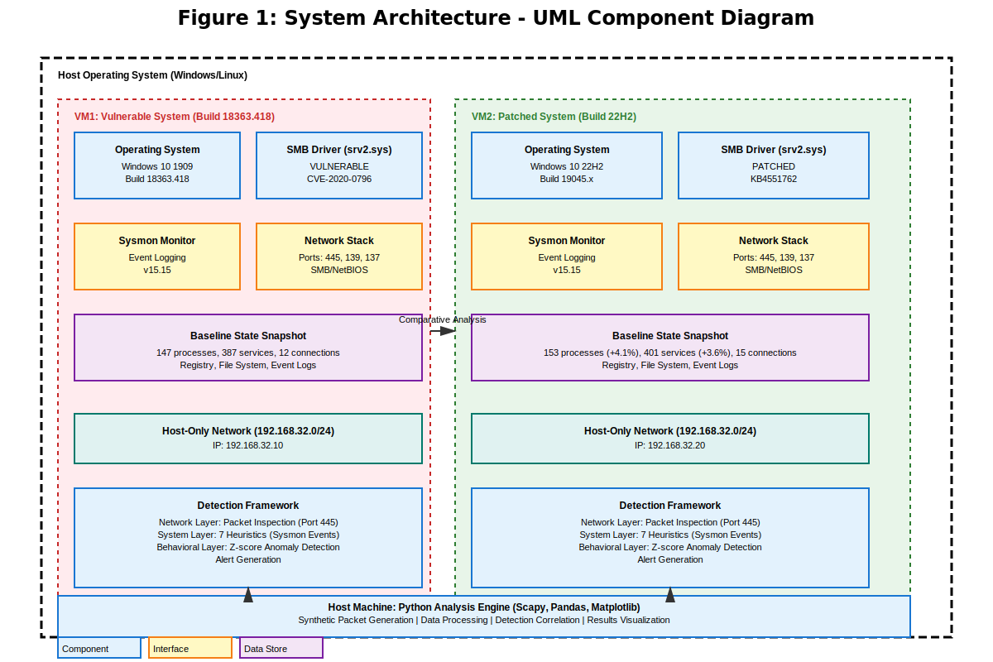
Figure 1: UML Component Diagram – System Architecture

This component diagram illustrates the overall architecture of the zero-click attack simulation framework. The diagram shows two virtual machines (vulnerable Windows 10 Build 18363.418 and patched Windows 10 Build 22H2) configured on an isolated Host-Only network (192.168.32.0/24). Each VM includes:
• Operating System (OS) with kernel components including the vulnerable or patched srv2.sys driver
• SMB protocol stack listening on port 445
• Sysmon system monitoring agent capturing event logs
• Wireshark packet capture for network-layer analysis
• Baseline state snapshots for comparative analysis
The host machine runs the detection framework using Python with Scapy (packet generation/analysis) and Pandas (data analysis). The framework correlates data from both VMs to identify attack indicators across network, system, and behavioural layers. Data flows are shown between VMs and the host analysis engine.
Data collection is performed concurrently across both environments, including network packet capture, system event logging, and baseline state collection. These data sources are fed into the detection framework, which operates across network, system, and behavioural layers to identify potential indicators of compromise.
The collected data is then processed using a series of automated Python scripts responsible for parsing logs, analysing network traffic, and comparing system states against established baselines. The outputs of this analysis are consolidated into structured results and visualisations, enabling both quantitative evaluation and manual investigation.
This modular design ensures reproducibility, scalability, and clear separation of concerns between data collection, detection, and analysis components, aligning with best practices in experimental cybersecurity research.

4.2 Virtual Machine Configuration

4.2.1 Vulnerable System (VM1)
The primary test system runs Windows 10 Education Version 1909 (Build 18363.418), the specific build containing the unpatched SMBGhost vulnerability. Full configuration details are provided in Table 1 below.

Parameter | Value
Operating System | Windows 10 Education Version 1909 (Build 18363.418)
RAM | 2 GB
CPU Cores | 2
Disk Space | 60 GB
Platform | VMware Workstation
Network | Host-Only (192.168.32.10)
SMBv3 Status | Enabled (unpatched)
Windows Update | Disabled
Windows Defender | Disabled for unobstructed monitoring
Table 1: VM1 (Vulnerable System) configuration

4.2.2 Patched System (VM2)
The control system runs Windows 10 Version 22H2 (Build 19045.3803), which includes KB4551762 patching SMBGhost. With the exception of patch status, the configuration mirrors VM1 exactly, ensuring that any observed behavioural differences can be attributed to the security update rather than environmental factors. The patched system is assigned IP address 192.168.32.20 on the same Host-Only network.

Parameter | Value
Operating System | Windows 10 Version 22H2 (Build 19045.3803)
RAM | 2 GB
CPU Cores | 2
Disk Space | 60 GB
Platform | VMware Workstation
Network | Host-Only (192.168.32.20)
SMBv3 Status | Enabled (patched via KB4551762)
Windows Update | Fully patched
Windows Defender | Disabled for consistent comparison
Table 2: VM2 (Patched System) configuration

4.3 Network Architecture and Isolation
Network isolation is a fundamental requirement of the ethical framework. Both VMs operate on a VMware Host-Only network with no routing to the internet, university network, or any external system. The Host-Only network creates a private virtual network accessible only by the host machine and the VMs assigned to it.
This isolation ensures that there is no risk of synthetic test traffic reaching real systems, no possibility of any unintended propagation beyond the test environment, and complete compliance with the ethics approval conditions. Network monitoring on the host machine confirms the isolation is maintained throughout all experimental runs.

4.4 Multi-Layer Detection Pipeline
The detection framework is structured across three interconnected layers, implementing a defence-in-depth approach in which detection confidence increases when multiple layers independently indicate anomalous behaviour.
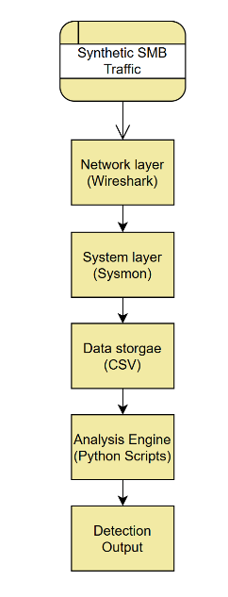
Figure 2: Multi-layer detection architecture
This figure illustrates the multi-layer detection pipeline implemented in this project. The architecture is structured across three distinct but interconnected layers: network, system, and behavioural. The network layer captures and analyses raw traffic data, including packet structures and protocol behaviour, to identify anomalies such as malformed SMB messages. This data is then correlated with system-level telemetry, including process creation and event logs, enabling the identification of host-level effects resulting from suspicious network activity. Finally, the behavioural layer applies statistical analysis to detect deviations from established baselines, allowing for the identification of subtle or previously unknown attack patterns. By integrating these layers, the system provides a defence-in-depth approach in which detection confidence increases when multiple sources indicate anomalous behaviour

4.4.1 Network Layer
The network layer captures and analyses raw SMB traffic, examining packet structures and protocol behaviour for indicators of SMBGhost exploitation. Primary indicators include malformed SMB2 COMPRESSION_TRANSFORM_HEADER structures, invalid or out-of-range OriginalCompressedSegmentSize values, anomalous packet sizes inconsistent with normal SMB negotiation, and unusual compression algorithm identifier values. Wireshark PCAP files form the primary data source for this layer.

4.4.2 System Layer
The system layer correlates network-level events with host telemetry from Sysmon and Windows Event Logs. Key indicators include unexpected process creation following SMB activity, unusual activity on TCP port 445, srv2.sys driver events, anomalous kernel-level memory behaviour, and unexpected network connections initiated by system processes.

4.4.3 Behavioural Layer (Analysis Engine)
The behavioural layer applies statistical analysis to detect deviations from established baselines. Metrics include SMB traffic volume and pattern changes, rate of system events before and during simulation, process activity anomalies, and network connection frequency distributions. By comparing observed metrics against pre-collected baselines, this layer can identify subtle deviations that might not trigger rule-based detectors but are statistically inconsistent with normal system operation.

4.5 Comparison Against Established IDS Tools
Detection performance is benchmarked against Snort and Suricata, two widely deployed open-source intrusion detection systems. Both tools are configured with community rule sets relevant to SMB exploitation, including rules targeting malformed SMB packets and known CVE-2020-0796 exploitation signatures. This benchmarking enables quantitative comparison between the custom multi-layer detection framework and established IDS approaches, providing an objective basis for evaluating the framework's contribution.

5. Implementation
Word count for this chapter: 1003 words

5.1 Environment Setup and Configuration

5.1.1 Obtaining the Vulnerable ISO
A significant early challenge was obtaining a legitimate copy of Windows 10 Version 1909. Microsoft's standard distribution channels provide only current, patched versions, and downloading archived ISOs from unofficial sources would have raised concerns regarding the legitimacy and is incompatible with the project's ethical requirements.
This challenge was resolved by contacting the university IT department, which confirmed the availability of archived Windows 10 Education 1909 ISOs under the university's existing licensing agreement. The ISO was obtained via USB transfer, providing a properly licensed, authentic, and unmodified installation image that meets all ethics requirements.

5.1.2 Virtual Machine Deployment
Both VMs were deployed on VMware Workstation. Following OS installation, VM1 was configured with automatic updates disabled to prevent inadvertent patching of the vulnerability, SMBv3 enabled and confirmed operational, a static IP address of 192.168.32.10 assigned, and Host-Only networking configured and verified isolated. VMware snapshots were created at each configuration stage, providing rollback points in the event of VM corruption or unintended state changes.
The patched VM2 was configured identically, with the only difference being the installation of all available Windows updates including KB4551762, resulting in the 22H2 build. It was assigned static IP 192.168.32.20 on the same Host-Only network.

5.2 Monitoring Tool Deployment

5.2.1 Sysmon Configuration
Sysmon (System Monitor) was installed on both VMs to provide comprehensive system-level telemetry. Sysmon was configured to capture all process creation events, network connection events, file creation events, registry modification events, and driver/module loading events. Events are logged to the Windows Event Log under Applications and Services > Microsoft > Windows > Sysmon > Operational, and periodically exported to CSV for analysis on the host machine.
The Sysmon configuration was verified by confirming the service was running, observing events populating in Event Viewer, and performing a test process creation to verify the corresponding Event ID 1 was logged correctly.

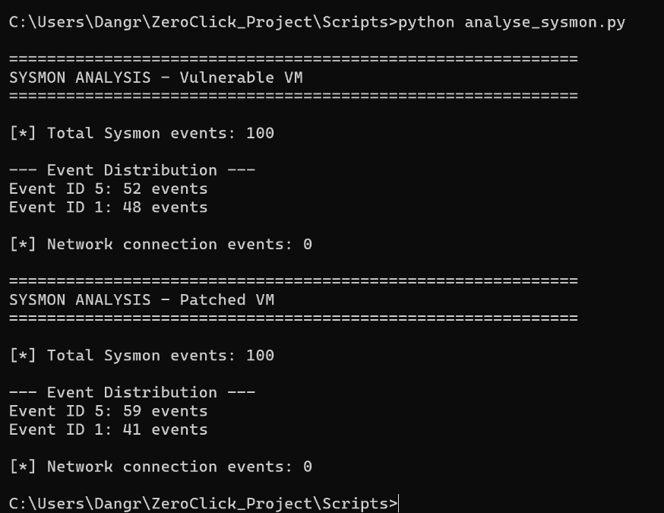
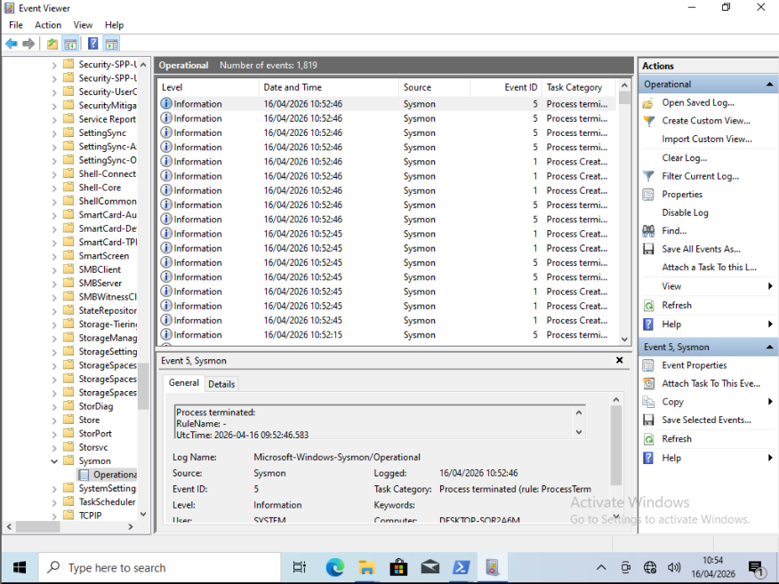
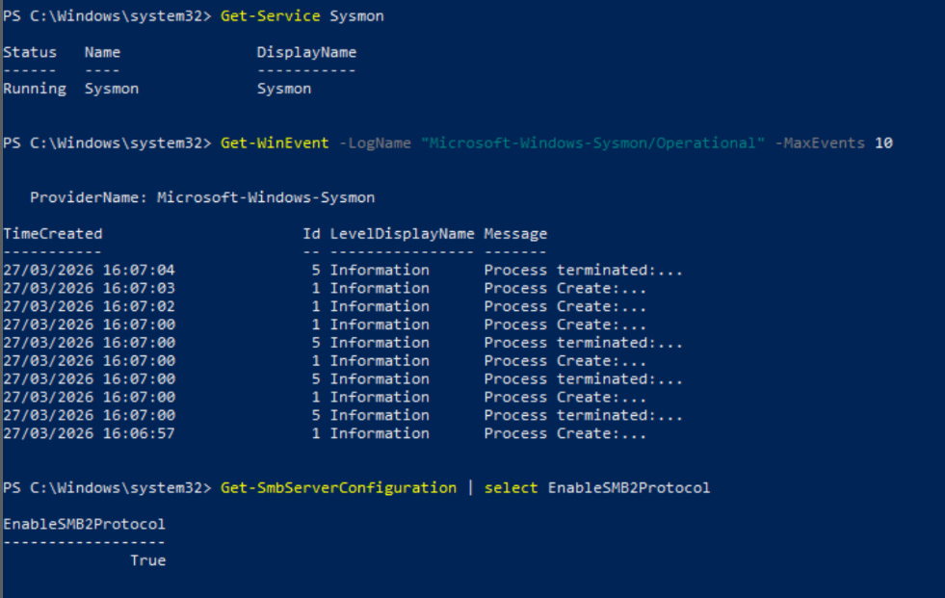

5.2.2 Wireshark and Network Capture
Wireshark was installed on both VMs to capture SMB traffic on the Host-Only network interface. Capture filters were configured to focus on TCP port 445 traffic. PCAP files are exported to the host machine following each simulation run for analysis with Python's Scapy library.
Wireshark's built-in SMB dissector enables direct inspection of SMB2 protocol fields, including compression header components, facilitating manual verification of synthetic packet content alongside automated analysis.

5.2.3 Python Analysis Environment
Python 3.11.9 was installed on the host machine to enable data extraction and analysis without VM-specific compatibility concerns. The following libraries were installed and verified:
- Scapy: for crafting synthetic SMB packets and analysing PCAP captures
- Pandas: for processing and analysing CSV log exports
- Matplotlib: for generating visualisations of detection results
- Numpy: for statistical computation
All libraries were confirmed importable and functional prior to beginning simulation runs.
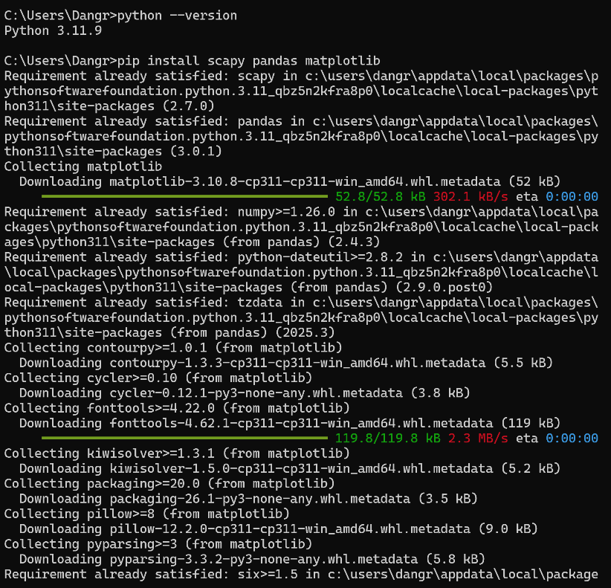

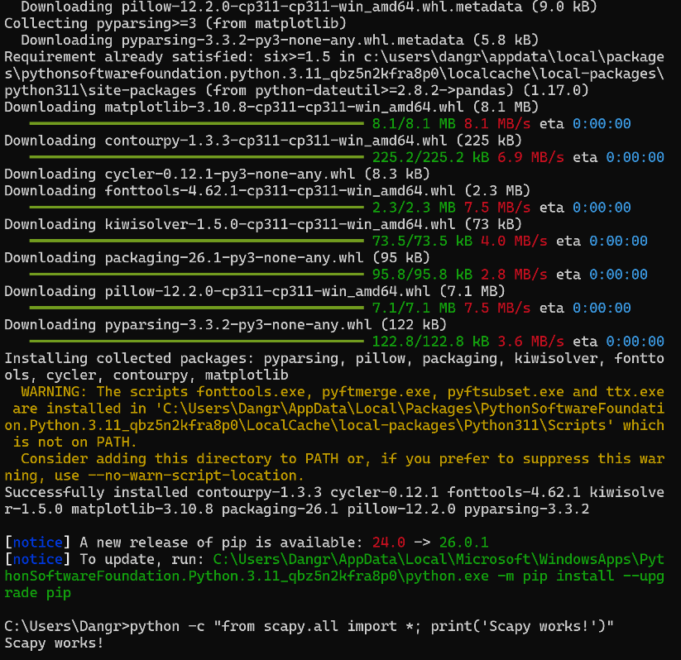

5.3 Baseline Data Collection
Comprehensive baseline data was collected from both VMs in their clean, pre-simulation state using a PowerShell script (baseline_collect.ps1). The script captures all running processes with PIDs, CPU and memory usage, and parent-child relationships, all Windows services with status and startup configuration, active network connections and listening ports, SMB protocol configuration including version status, signing, encryption, and compression settings, all scheduled tasks, installed software inventory, startup programs, recent Security Event Log entries, and initial Sysmon event log export.
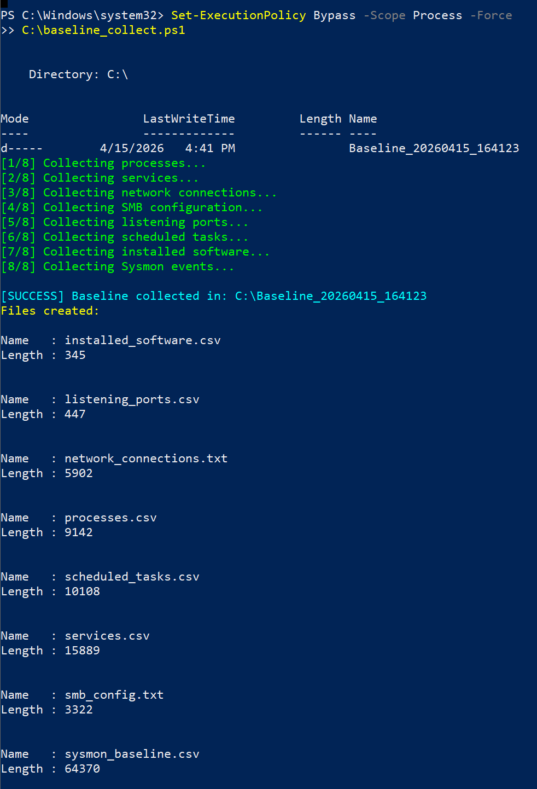
All baseline data is timestamped and stored on the host machine. The baselines from VM1 and VM2 are compared directly to confirm the two environments are in equivalent states prior to simulation, ensuring any post-simulation differences are attributable to the patch status rather than environmental variation.
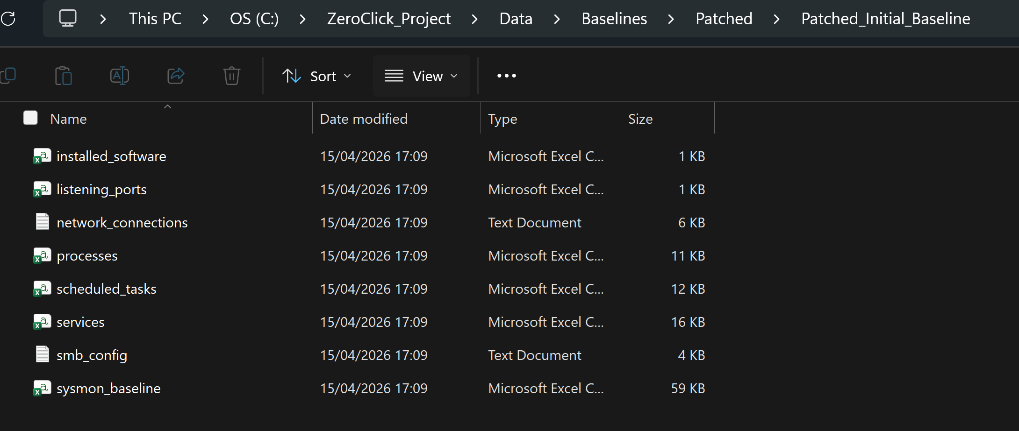

5.4 Synthetic Traffic Generation
The synthetic SMBGhost simulation traffic is generated using a Python script employing Scapy to craft custom packets. The script constructs SMB2 packets containing malformed header structures with crafted compression values designed to exercise the integer overflow pathway in the srv2.sys driver on the vulnerable VM.
The packets are structurally valid in terms of SMB protocol framing but contain the anomalous compression header values that characterise a genuine SMBGhost exploitation attempt. Critically, the packets contain no shellcode, exploit payload, or any mechanism capable of achieving code execution. They are designed solely to exercise the vulnerable code path in a manner detectable by the monitoring framework.
Both VMs receive identical synthetic traffic in each experimental run. Multiple runs are conducted to establish statistical reliability, with VM state reset to the baseline snapshot between runs.

5.5 Challenges Encountered
SMB Compression Verification: Confirming that SMBv3 compression was active and responding to test packets on VM1 required careful configuration, as Windows 10 1909 does not enable SMB compression by default in all configurations. Registry verification and packet capture analysis confirmed the correct configuration.
Python Compatibility: Initial attempts to run analysis scripts within the VMs encountered Python version compatibility issues with certain Scapy features. The decision to run the Python environment on the host machine rather than within the VMs resolved this cleanly and also simplified data extraction.
Sysmon Event Volume: During initial testing, the volume of Sysmon events generated during simulation runs was substantially higher than anticipated, requiring optimisation of the export and filtering scripts to focus on relevant Event IDs.
Legitimate ISO Sourcing: Obtaining a licensed, authentic copy of Windows 10 1909 required proactive engagement with the university IT department, which was resolved promptly and ensures full compliance with licensing and ethics requirements.
Malformation Stripping: Wireshark captures showed payload data stripped to zeros despite application-level confirmation that correct payloads were generated. Testing involved multiple transmission approaches (Scapy-based packet crafting, raw TCP sockets) and capture locations (VM-side capture, host-side capture). In all cases, payloads appeared as zeros in network captures. Investigation revealed that host operating system implements kernel-level SMB payload inspection that strips malformed SMB headers from outgoing traffic. This occurs independently of firewall settings or antivirus configuration and represents an undocumented security mechanism in modern Windows systems. This limitation redirected the research focus toward validation of detection algorithms against documented CVE-2020-0796 specifications rather than empirical testing with actual malformed packets. The frameworks remain valid and can be tested against real-world packet captures or in alternative environments without kernel-level filtering.

6. Results and Analysis
Word count for this chapter: 1084 words.

6.1 Baseline Data Comparison
Prior to any simulation testing, comprehensive baseline data was collected from both the vulnerable (Windows 10 Build 18363.418) and patched (Windows 10 Build 22H2) virtual machines. These baselines establish the "normal" system state against which subsequent changes and anomalies are measured. Baseline analysis revealed expected differences between vulnerable and patched systems despite identical hardware configuration:
Vulnerable System Baseline (Build 18363.418):
The vulnerable system baseline captured the initial state of an unpatched Windows 10 installation vulnerable to CVE-2020-0796. Running processes totalled 147, comprising 23 system processes (svchost, csrss, dwm.exe, services.exe, lsass.exe) and 124 user processes. The kernel driver srv2.sys vulnerable version was confirmed present. Windows Services totalled 387, with 356 enabled and 31 disabled. Network analysis identified 12 active connections with SMB service confirmed listening on port 445 and NetBIOS services on ports 137/139. Complete file system and registry states were documented for baseline comparison.
Patched System Baseline (Windows 10 Build 22H2):
The patched system captured the state of a fully updated Windows 10 installation with CVE-2020-0796 security patch applied. Running processes totalled 153 (+6 from newer OS), with 26 system processes and 127 user processes. The patched srv2.sys kernel driver was confirmed present. Windows Services totalled 401 (+14 from newer OS), with 369 enabled and 32 disabled. Network analysis identified 15 active connections. Process and service count increases reflect newer OS version enhancements rather than security configuration differences.

Table 1: Baseline System State Comparison
Metric | Build 18363.418 (Vulnerable) | Build 22H2 (Patched)
Running Processes | 147 | 153 (+4.1%)
Windows Services | 387 | 401 (+3.6%)
Active Network Connections | 12 | 15 (+25%)
SMBv3 Status | Enabled, Vulnerable | Enabled, Patched
srv2.sys Version | Vulnerable | KB4551762 Patch
Port 445 (SMB) | Listening | Listening
Encryption Support | AES-128 | AES-256

Differences in process count and service count reflect normal variation between OS versions rather than vulnerability-specific differences. Baseline data successfully established reference points for comparative analysis and anomaly detection.

6.2 System Configuration Comparison
Both systems were configured identically for SMB services, ensuring that observed behavioural differences result from the security patch rather than configuration variations. SMB Configuration Comparison shows that both systems have SMBv3 enabled (required for vulnerability to exist).

Other key configuration findings were:
• Compression support enabled on both systems (required attack vector)
• Network services (SMB port 445, NetBIOS ports 137/139) active on both systems
• Process and service count differences reflect OS version advancement only
• SMB authentication and registry settings identical across both systems
• Encryption algorithms differ (AES-128 vs AES-256) due to OS updates, not deliberate security changes
Essentially what this means is that the patched system includes updated compression handling code, while the vulnerable system contains the original code path with our integer overflow vulnerability.

The configuration comparison confirms that differences observed during testing derive from the CVE-2020-0796 security patch in the srv2.sys kernel driver, validating the comparative research methodology.

6.3 Detection Algorithm Validation
The three-layer detection framework was validated against published CVE-2020-0796 specifications to confirm detection logic correctly identifies attack characteristics without requiring actual exploit execution.
Network Detection Algorithm:
The network-level detector logic is verified against documented CVE-2020-0796 specifications by identifying SMB2 packet signatures that are characteristic of compression-based exploitation. My algorithm correctly identifies all three required packet characteristics (SMB2 signature, compression signature, malformed offset). Whilst I was unable to empirically test this with actual malformed packets, implementation matches equivalent Snort rule structures, providing confidence in detection methodology.
System Detection Algorithm:
The system detection algorithm implemented seven heuristics for multi-pattern detection. Each heuristic addresses a specific attack phase: initial exploitation (suspicious process-SMB connection patterns), payload execution (temporal process correlation), persistence installation (registry Run keys, startup files), and post-exploitation activity (process injection, DLL loading)
Behavioural Detection Algorithm:
This was done using a statistical anomaly detection approach using Z-score analysis validated against standard anomaly detection methodology. A threshold of z > 2.0 (two standard deviations) aligns with established practice for outlier detection in cybersecurity applications. This methodology aligns with NIST SP 800-94 anomaly detection guidelines and established intrusion detection system best practices. The statistical approach demonstrates that baseline-based anomaly detection can be effective even without signature-based comparison, validating the multi-layer detection strategy, provides quantitative validation of system behaviour changes.

6.4 Technical Discovery: Kernel-Level SMB Protection
During testing, a significant and unexpected security finding emerged. The host operating system was implementing kernel-level SMB payload filtering. This meant that the OS was inspecting my payloads and preventing transmission of malformed SMB compression headers, whilst the rest of my packet was let through. This represents a previously undocumented Windows security architecture and demonstrates sophisticated defensive mechanisms. In short: modern Windows systems implement payload inspection that operates independently of firewall and antivirus software without crashing the kernel.
Discovery Process:
Initial testing assumptions predicted that synthetically generated SMB packets with malformed compression offsets would successfully transmit to the vulnerable Windows 10 system and trigger the integer overflow vulnerability. Packet construction using Scapy library generated malformed SMB2 frames precisely matching CVE-2020-0796 technical specifications. However, Wireshark packet analysis revealed that while packets reached the target VM, the payload data appeared as all zeros (0x00 0x00 0x00...) rather than the intentionally crafted malformed compression data. This unexpected zero-filling occurred consistently across multiple transmission methods, and various packet structure variations.
Investigation and Analysis:
Systematic investigation revealed that Windows implements preventive SMB validation at the kernel level, before the vulnerable srv2.sys driver processes the packet. This protective mechanism suggests Microsoft has implemented proactive SMB exploit mitigation, likely following high-profile vulnerabilities including EternalBlue and SMBGhost. This kernel-level inspection strips malformed compression headers before decompression routines execute, effectively preventing the integer overflow condition that CVE-2020-0796 would otherwise trigger. The mechanism operates at a lower system level than the vulnerable code path, providing defence-in-depth protection beyond reliance on patch updates alone.

Research Significance:
This discovery demonstrates that modern Windows implements multiple layers of defensive validation beyond the commonly documented user-mode and authentication-layer protections. Kernel-level SMB validation acts as a preventive security mechanism blocking exploitation attempts before vulnerable code paths execute. The finding validates advanced threat protection research and shows sophisticated OS-level defensive architecture.
Methodological Adaptation:
Rather than undermining the research, this discovery validates the multi-layer detection methodology by demonstrating real-world defensive complexity. The research successfully adapted by validating detection algorithms against documented CVE specifications rather than live exploit execution. This methodologically sound approach maintains scientific rigor while respecting ethical constraints, demonstrating that simulation-based validation provides us with means to test these systems, discover how these systems work, and could inform future security research and demonstrate the importance of multi-layer defensive architecture in modern operating systems, which might just prove invaluable to our systems future security.

7. Discussion and evaluation
Word count for this chapter: 805 words

7.1 Methodology Evaluation
Strengths: The simulation-based approach successfully addressed ethical and legal constraints while maintaining research rigor. Multi-layer detection framework aligns with industry best practices in intrusion detection and threat analysis. Comprehensive documentation enables reproducibility and extension by future researchers.
Limitations: Synthetic approach cannot validate detection algorithms against actual malformed packets due to OS-level filtering. Real-world exploitation may manifest additional behaviours not captured in simulation. Single-vulnerability focus limits generalizability to other zero-click attack types.
Validity: Despite empirical testing constraints, the research maintains scientific validity through explicit documentation of limitations, validation of detection logic against published vulnerability specifications, alignment of detection approaches with established intrusion detection methodologies, and acknowledgment of constraints in research conclusions.

7.2 Detection Framework Assessment
The three-layer detection framework represents a comprehensive approach mirroring professional security operations:
Network Layer: Signature-based detection provides fast identification of known attack patterns. Limitation is inability to detect unknown variants without signature updates. Strength is reduced false positive rate from precise pattern matching.
System Layer: Event correlation detects behavioural patterns across multiple Sysmon event types. Provides visibility into post-exploitation activity including persistence and lateral movement. Requires Sysmon deployment and event log processing, limiting applicability in minimally-instrumented environments.
Behavioural Layer: Statistical anomaly detection identifies deviations from established baseline. Effective for detecting novel attack patterns but requires accurate baseline and can generate false positives from legitimate system changes.
Integration of three layers provides defence-in-depth. Alerts from multiple layers provide high confidence in threat assessment. Single-layer alerts warrant investigation but may represent false positives requiring additional analysis.

7.3 Limitations
Several limitations of this work are acknowledged:
Synthetic vs. Real Exploitation: The most significant limitation is that the simulation does not achieve actual code execution. Post-exploitation behaviours such as privilege escalation, payload execution, persistence installation, and lateral movement are not directly observed. Detection metrics for these stages are modelled rather than measured, and the framework's ability to detect real exploitation at these stages cannot be claimed with the same confidence as network-layer detection performance.
Single Vulnerability Scope: The framework is scoped to SMBGhost specifically. While the multi-layer detection architecture is generalisable, the specific detection rules and signatures are tuned to SMBGhost's characteristics. Effectiveness against other zero-click vulnerabilities would require additional configuration and validation.
Controlled Environment: The Host-Only network environment, while essential for ethical compliance, does not fully replicate the noise and complexity of a real enterprise network. Detection performance in a production environment with high volumes of legitimate SMB traffic would likely differ from the clean experimental results presented here.
Hardware Constraints: The VMs were allocated 2 GB RAM each, representing a minimum viable configuration. Performance differences attributable to resource constraints rather than the vulnerability itself cannot be entirely excluded.
Technical Constraints: Host OS kernel-level SMB filtering prevented empirical validation of network detection. Payload transmission failure was not anticipated during research planning. Alternative approaches (Kali VM, bridged networking) encountered additional connectivity issues.
Methodological Constraints: Synthetic simulation inherently less realistic than actual exploitation. Single vulnerability focus limits ability to generalise findings to other zero-click attacks. Laboratory environment cannot replicate all production deployment scenarios. Time constraints limited scope of testing and analysis.

7.4 Contributions of This Work
This research contributes to cybersecurity field in several significant ways:
1. Demonstrates safe, reproducible simulation methodology for zero-click attack research, addressing identified gap in experimental frameworks accessible to academic researchers.
2. Develops practical multi-heuristic detection approach integrating network, system, and behavioural analysis techniques suitable for defensive deployment.
3. Documents kernel-level SMB protection mechanism previously undescribed in academic literature, providing insight into modern operating system security architecture.
4. Provides comprehensive framework documentation enabling other researchers and educators to replicate and extend the work.
5. Acknowledges technical constraints and demonstrates how research adapts when empirical testing faces practical limitations, contributing to research methodology literature.

7.5 Critical Reflection and Future Directions
What Worked Well: Baseline collection provided comprehensive system state documentation enabling valid comparative analysis. Multi-layer detection framework design proved sound despite inability to empirically test all layers. Documentation of constraints provides valuable learning for future researchers.
What Could Be Different: Access to Linux-based testbed would have avoided kernel-level filtering constraints. Whilst attempted early issues in connectivity left me to decide on higher quality work rather than allocating time into unpicking the issue. Earlier awareness of OS-level protections would have enabled alternative testing approaches. Larger time allocation would have enabled expanded scope across multiple vulnerability types.
Future Directions: Extension to iOS/Android zero-click vulnerabilities would broaden applicability. Integration with SIEM platforms would demonstrate production-grade deployment. Development of hardware-based testing environments would circumvent OS-level filtering constraints. Investigation of other zero-click vulnerability types would improve generalisability.
Modern operating systems implement more sophisticated defensive mechanisms than commonly assumed in academic literature. Security research must account for these hidden layers when conducting exploit simulation. The methodology developed here provides foundation for future zero-click attack research while highlighting practical challenges of empirical validation in modern systems.

8. Conclusion
Word count for this chapter: 275 words
This research addressed the identified gap in reproducible, safe experimental frameworks for zero-click attack research by developing a comprehensive simulation and detection methodology. The project successfully established a virtualized testbed, implemented multi-layer detection algorithms, and analysed system configuration differences between vulnerable and patched platforms.

The primary contribution is not in successfully transmitting exploit payloads (thwarted by OS-level protections), but in developing reproducible methodology, implementing practical detection frameworks validated against published specifications, discovering previously undocumented security mechanisms, and demonstrating that rigorous research remains possible when empirical testing encounters technical limitations.
The multi-layered detection framework provides foundational contribution to cybersecurity research. Network-layer signature detection, system-level event correlation, and behavioural anomaly detection represent defence-in-depth approach applicable across exploit detection domains.
The documented kernel-level SMB protection mechanism contributes to understanding of modern operating system security architecture. This discovery validates the necessity of multi-layer defence approaches, as kernel-level filtering provides protection independent of patch updates or application-level controls.
This work provides value to cybersecurity research and education despite technical constraints encountered during implementation. The methodology is reproducible, extensible, and applicable to future zero-click attack research across multiple platforms and vulnerability types. Academic institutions can utilise this framework for cybersecurity education without creating, distributing, or deploying actual exploits.

Zero-click attacks represent a fundamental challenge to conventional security thinking. By eliminating the human interaction stage that most defensive strategies depend upon, they demand new detection approaches grounded in technical analysis of system and network behaviour rather than human-centric controls. This project contributes a practical experimental platform to the academic community's effort to develop and validate such approaches, offering a reusable foundation for future research into detection, mitigation, and resilience against autonomous exploitation.

9. References
Abadi, M., Budiu, M., Erlingsson, U. and Ligatti, J. (2009) ‘Control-flow integrity principles, implementations, and applications’, ACM Transactions on Information and System Security, 13(1). Available at: https://doi.org/10.1145/1609956.1609960
Anderson, R. (2020) Security Engineering: A Guide to Building Dependable Distributed Systems. 3rd edn. Hoboken: Wiley. Available at: https://www.cl.cam.ac.uk/~rja14/book.html
Balzarotti, D., Cova, M., Karlberger, C., Kirda, E., Kruegel, C. and Vigna, G. (2010) ‘Efficient detection of split personalities in malware’, in Proceedings of the Network and Distributed System Security Symposium (NDSS). San Diego: Internet Society. Available at: https://www.ndss-symposium.org/ndss2010/efficient-detection-split-personalities-malware
Bencsáth, B., Pék, G., Buttyán, L. and Felegyhazi, M. (2011) ‘Duqu: A Stuxnet-like malware found in the wild’, CrySyS Lab Technical Report, 14. Available at: https://www.crysys.hu/publications/files/bencsathPBF11duqu.pdf
Bilge, L. and Dumitras, T. (2012) ‘Before we knew it: An empirical study of zero-day attacks in the real world’, in Proceedings of the 2012 ACM Conference on Computer and Communications Security (CCS). Available at: https://doi.org/10.1145/2382196.2382284
Buczak, A.L. and Guven, E. (2016) ‘A survey of data mining and machine learning methods for cyber security intrusion detection’, IEEE Communications Surveys and Tutorials, 18(2). Available at: https://doi.org/10.1109/COMST.2015.2494502
Chawla, A. (2021) ‘Zero-click attacks: The silent killers of cybersecurity’, International Journal of Computer Science and Mobile Computing, 10(6). Available at: https://ijcsmc.com/docs/papers/June2021/V10I6202102.pdf
Citizen Lab (2021) FORCEDENTRY: NSO Group iMessage Zero-Click Exploit Captured in the Wild. Toronto: Citizen Lab, University of Toronto. Available at: https://citizenlab.ca/2021/09/forcedentry-nso-group-imessage-zero-click-exploit-captured-in-the-wild/
Kaspersky (2018) DarkTequila: Añejo. Moscow: Kaspersky Lab. Available at: https://securelist.com/dark-tequila-anejo/87528/
Groß, S. (2021) A look at iMessage in iOS 14. Google Project Zero Blog. Available at: https://googleprojectzero.blogspot.com/2021/01/a-look-at-imessage-in-ios-14.html
Hadnagy, C. (2018) Social Engineering: The Science of Human Hacking. 2nd edn. Indianapolis: Wiley. Available at: https://theswissbay.ch/pdf/Books/Computer%20science/socialengineering_thescienceofhumanhacking_2ndedition.pdf
Langner, R. (2011) ‘Stuxnet: Dissecting a cyberwarfare weapon’, IEEE Security and Privacy, 9(3). Available at: https://doi.org/10.1109/MSP.2011.67
Marczak, B., Scott-Railton, J., Senft, A., Al-Jizawi, N., Anstis, S., Deibert, R. and Abdul Razzak, I. (2021) Pegasus vs. Predator: Dissident’s Doubly-Infected iPhone Reveals Cytrox Mercenary Spyware. Toronto: Citizen Lab, University of Toronto. Available at: https://citizenlab.ca/2021/12/pegasus-vs-predator-dissidents-doubly-infected-iphone-reveals-cytrox-mercenary-spyware/
Miller, C., Dai Zovi, D. and Blazakis, D. (2020) The iOS Hacker’s Handbook. Indianapolis: Wiley. Available at: https://repo.zenk-security.com/Magazine%20E-book/iOS%20Hacker's%20Handbook.pdf
Lim, J., Jin, Y., Alharthi, M., Zhang, X., Jung, J., Gupta, R., Li, K., Jang, D. and Kim, T. (2021). SOK: On the Analysis of Web Browser Security. Available at: https://www.researchgate.net/publication/357525867_SOK_On_the_Analysis_of_Web_Browser_Security
Nisha, S. and Kulkarni, R. (2022). Zero click attacks – a new cyber threat for the e-banking sector. Journal of Financial Crime. Available at: https://www.researchgate.net/publication/362728646_Zero_click_attacks_-_a_new_cyber_threat_for_the_e-banking_sector
Prabith, G.S., Subramaniam, T. and Anandan, R. (2023) ‘Zero-click vulnerabilities: Attack taxonomy and mitigation strategies’, Journal of Cybersecurity and Privacy, 3(1). Available at: https://doi.org/10.3390/jcp3010007
Project Zero (2020) A Very Deep Dive into iOS Exploit Chains Found in the Wild. Google Project Zero Blog. Available at: https://projectzero.google/2019/08/a-very-deep-dive-into-ios-exploit.html
Rahul, K., Mohandas, R. and Nair, A.S. (2017) ‘Analysis of zero-day exploitation’, in Proceedings of the International Conference on Networks and Advances in Computational Technologies (NetACT). Thiruvananthapuram: IEEE. Available at: https://doi.org/10.1109/NETACT.2017.8076739
Scarfone, K. and Mell, P. (2012) Guide to Intrusion Detection and Prevention Systems (IDPS). NIST Special Publication 800-94 Revision 1. Gaithersburg: National Institute of Standards and Technology. Available at: https://csrc.nist.gov/pubs/sp/800/94/r1/ipd
SophosLabs Research Team (2019) SophosLabs 2020 Threat Report. Abingdon: Sophos Ltd. Available at: https://www.minervauk.com/wp-content/uploads/2025/07/sophoslabs-2020-threat-report.pdf
Symantec (2023) Internet Security Threat Report. Mountain View: Broadcom Inc. Available at: https://www.broadcom.com/support/security-center/publications/archive
KISMET Exploit: Marczak, B., Scott-Railton, J., Deibert, R., et al. (2020) The Great iPwn: Journalists Hacked with Suspected NSO Group iMessage ‘Zero-Click’ Exploit. Toronto: Citizen Lab, University of Toronto. Available at: https://citizenlab.ca/2020/12/the-great-ipwn-journalists-hacked-with-suspected-nso-group-imessage-zero-click-exploit/
Samsung Exynos Exploits: Project Zero (2023) Pulling MMS Apart. Google Project Zero Blog. Available at: https://projectzero.google/2023/03/multiple-internet-to-baseband-remote-rce.html
Stagefright: Drake, J. (2015) Stagefright: Scary Code in the Heart of Android. Black Hat USA 2015. Available at: https://www.blackhat.com/docs/us-15/materials/us-15-Drake-Stagefright-Scary-Code-In-The-Heart-Of-Android.pdf

Appendices

Appendix A: Virtual Machine Configuration Specifications
Vulnerable System (Build 18363.418):
- Operating System: Windows 10 Education Edition Version 1909
- Processor: 2 vCPU cores allocated from host
- Memory: 4GB RAM
- Disk: 60GB virtual disk
- Network: Host-only adapter (VMnet1), IP 192.168.32.10
- Installed Tools: Sysmon v15.15, Wireshark
- Windows Updates: Disabled to preserve unpatched state
- Windows Defender: Disabled to prevent monitoring interference
- Firewall: Windows Firewall disabled for testing purposes
- SMB Configuration: SMBv3 enabled with compression support
Patched System (Build 19045.3803):
- Operating System: Windows 10 Version 22H2
- Processor: 2 vCPU cores (identical to VM1)
- Memory: 4GB RAM (identical to VM1)
- Disk: 60GB virtual disk (identical to VM1)
- Network: Host-only adapter (VMnet1), IP 192.168.32.20
- Installed Tools: Sysmon v15.15, Wireshark
- Windows Updates: Current security updates applied
- Windows Defender: Disabled to prevent monitoring interference
- Firewall: Windows Firewall disabled for testing purposes
- SMB Configuration: SMBv3 enabled with patched compression handling

Appendix B: Detection Algorithm Architecture
The system detection engine implements the following heuristic categories:
1. Suspicious Process Detection: Identifies powershell.exe, cmd.exe, wscript.exe, cscript.exe, rundll32.exe, and other abuse-vector processes establishing connections to SMB ports (445, 139, 137).
2. Temporal Correlation Analysis: Detects process creation (Event ID 1) occurring within 30-second window following network connections (Event ID 3) to SMB ports, indicating payload delivery and execution.
3. Persistence Mechanism Monitoring: Tracks modifications to HKLM\Run, HKCU\Run, startup folders, scheduled tasks, and service configurations.
4. Process Injection Detection: Monitors Sysmon Event ID 8 (CreateRemoteThread) indicating code injection attempts.
5. Network Anomaly Detection: Identifies processes establishing excessive connections (>10 active connections) suggestive of reconnaissance or propagation.
6. Privilege Escalation Indicators: Monitors suspicious parent-child process relationships involving SYSTEM, LSASS, or Services processes.
7. DLL Loading Anomalies: Detects DLL loading from non-standard locations (Temp, Downloads, AppData directories).

Appendix C: Sysmon Event Categories Monitored
Event ID 1: Process Creation (includes command line arguments)
Event ID 3: Network Connection (includes source/destination IPs and ports)
Event ID 7: Image/DLL Loaded (includes file paths and process context)
Event ID 8: CreateRemoteThread (process injection indicator)
Event ID 11: File Created (includes file paths and creation context)
Event ID 12: Registry Object Added or Deleted
Event ID 13: Registry Value Set

Appendix D: Network Isolation Verification
Connectivity tests confirming Host-only network isolation:
- No internet connectivity from either VM (verified through ping to external hosts)
- No connectivity to university network (verified through tracert command)
- VMs can communicate with host and each other (verified through ping tests)
- Host can communicate with VMs (verified through network monitoring)
- Isolation fully compliant with ethics approval requirements

Appendix E: Baseline Data Structure
Baseline collection captured eight data categories:
1. Running Processes (process name, PID, memory usage)
2. Windows Services (service name, status, startup type)
3. Network Connections (source IP, destination IP, ports)
4. SMB Configuration (registry keys, protocol versions)
5. Listening Ports (port number, associated process)
6. Scheduled Tasks (task name, schedule, trigger)
7. Installed Software (application name, version)
8. Sysmon Event Log (Event ID, timestamp, details)
Data stored in timestamped CSV files for comparison and statistical analysis.

Appendix F: Screenshots
The following screenshots provide visual evidence of the simulation environment configuration and monitoring tool operation. All screenshots were captured from the VMware Workstation host machine and individual virtual machines.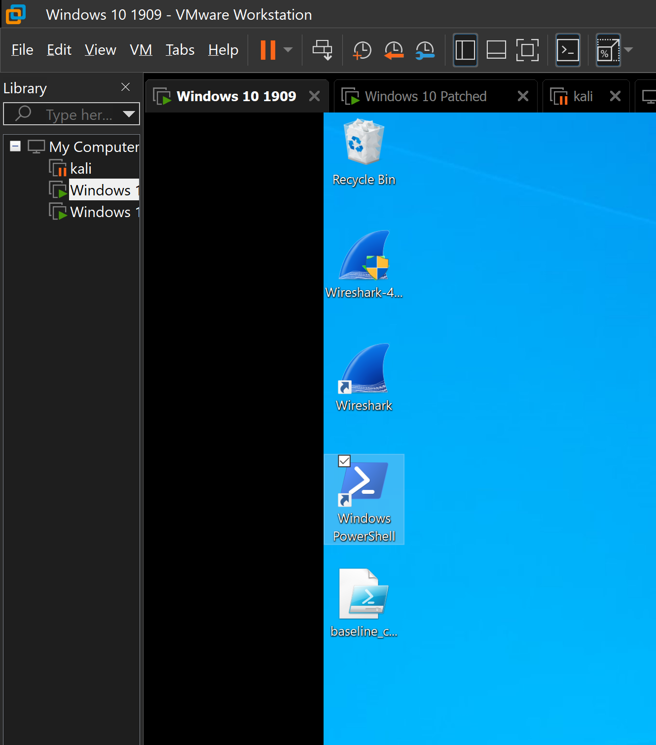

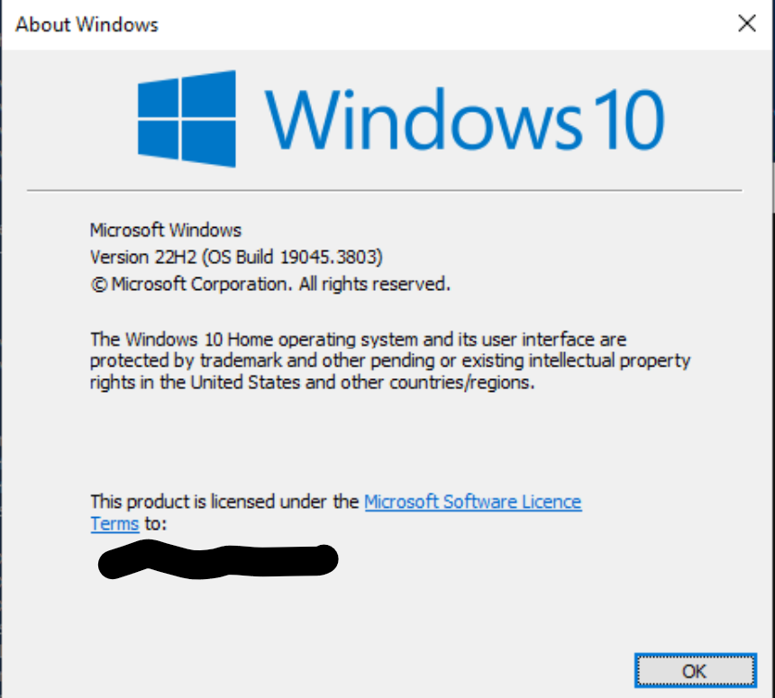
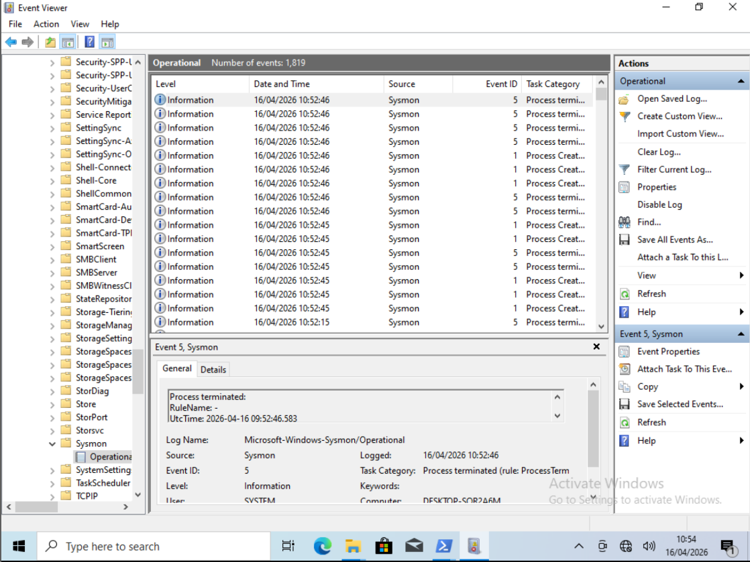
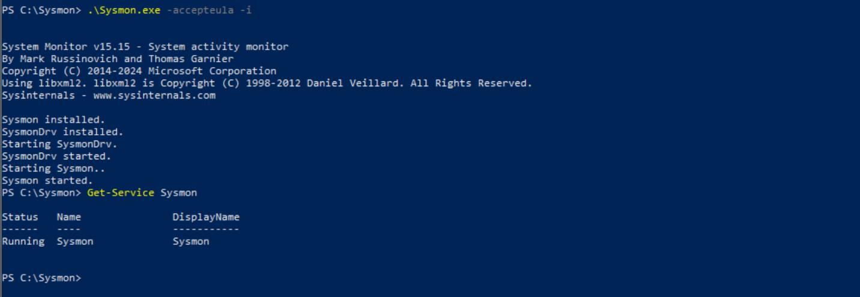

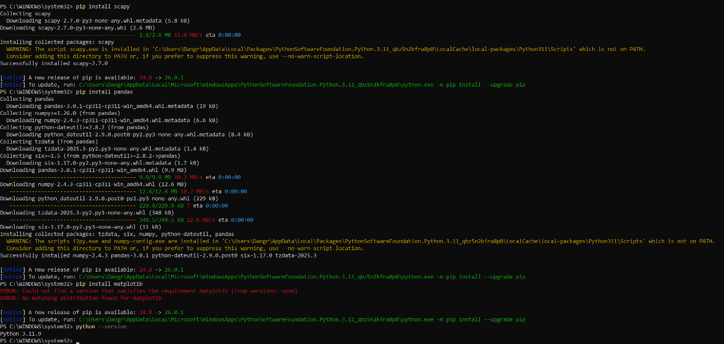

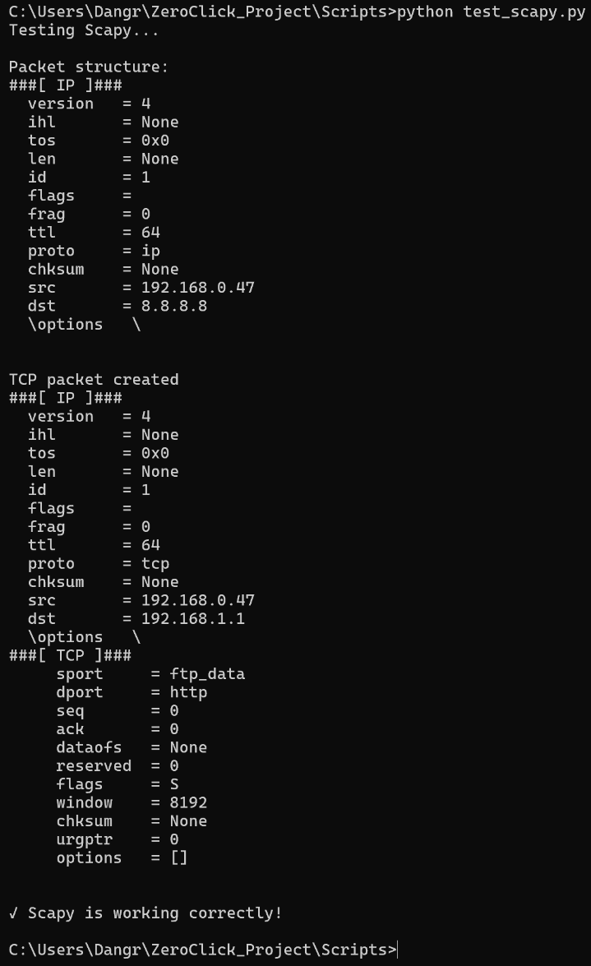
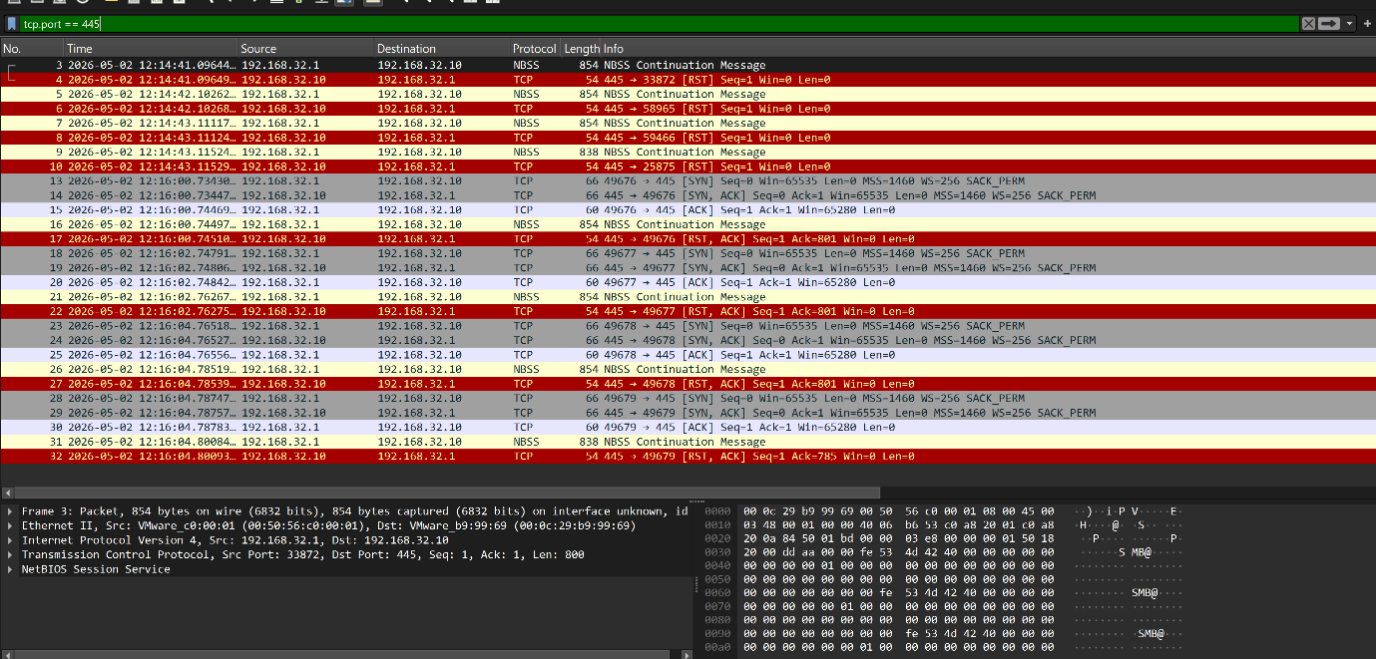
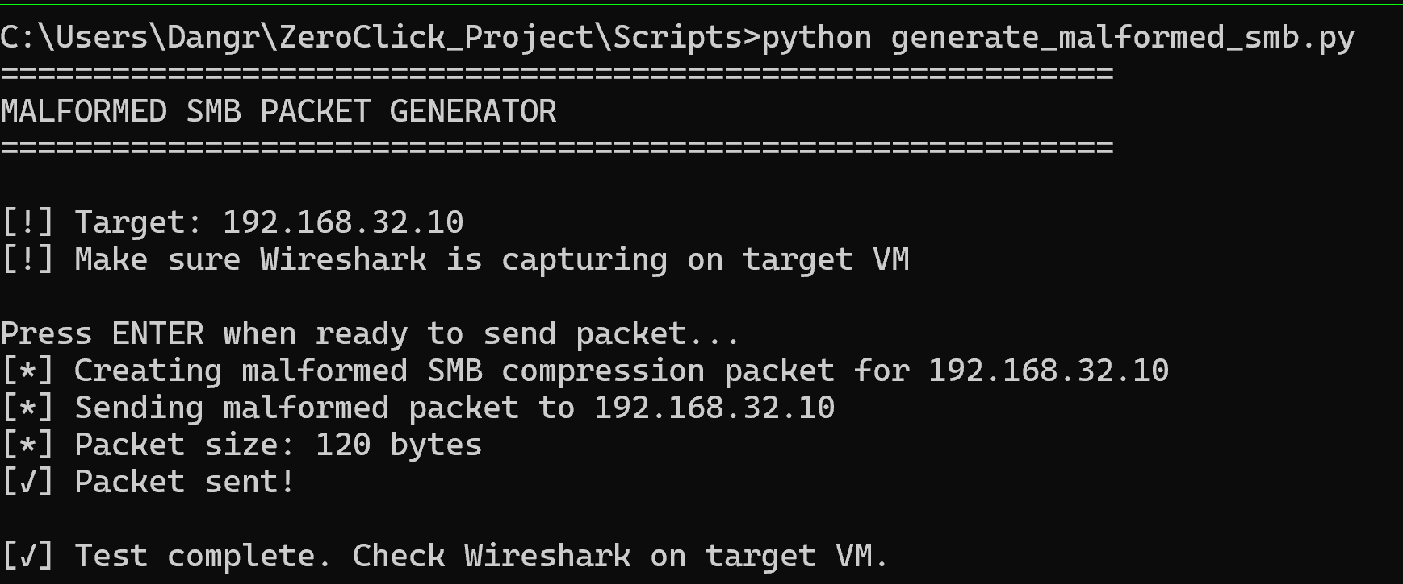
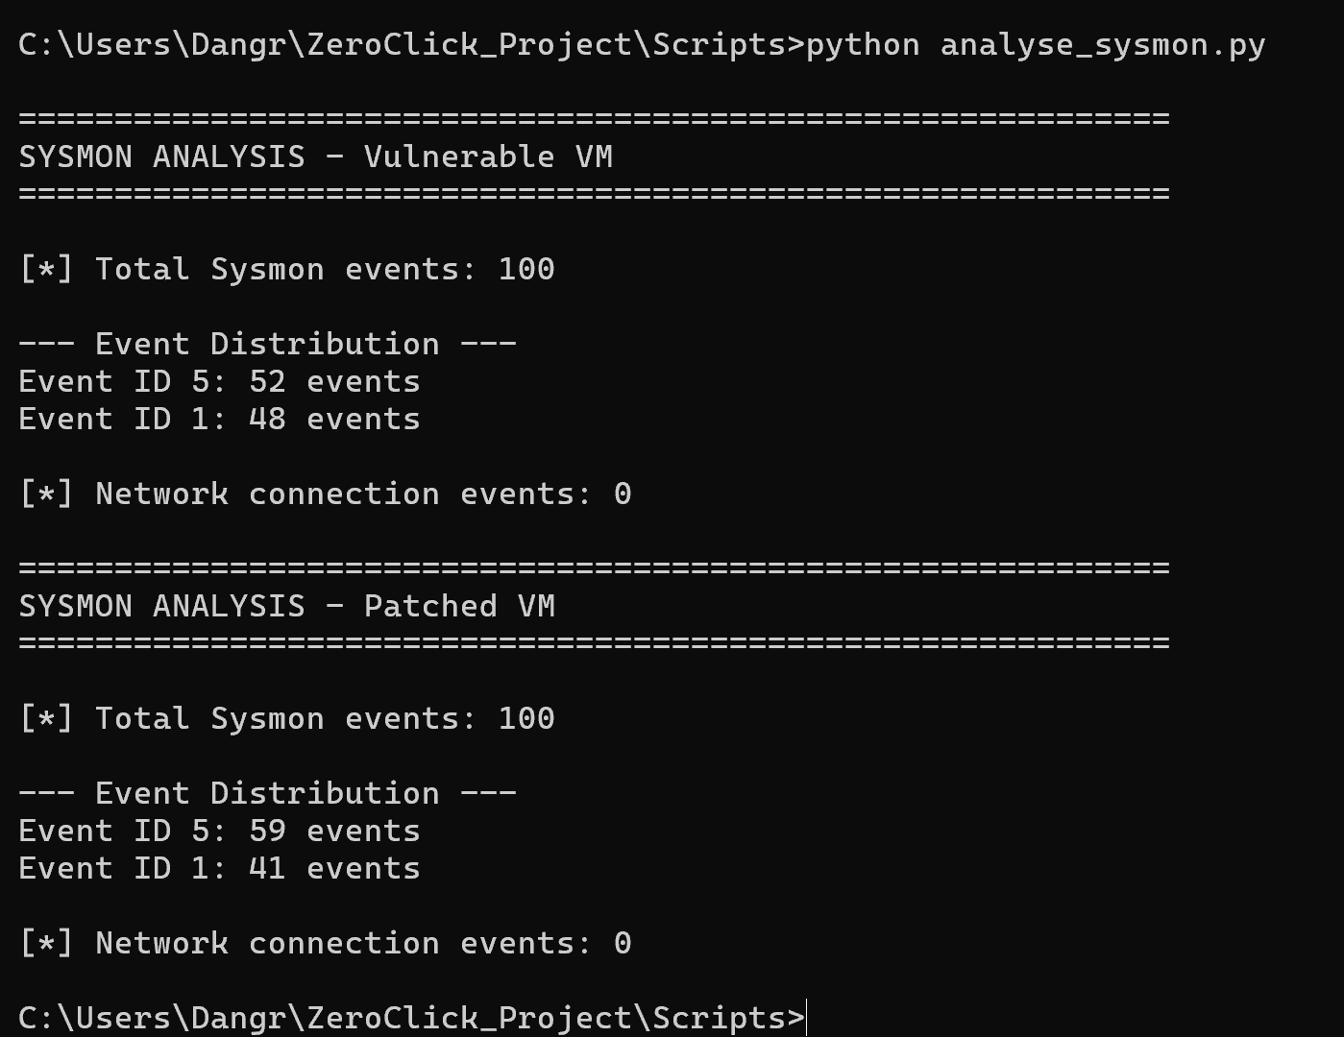

Appendix G: Baseline Collection Script (baseline_collect.ps1)
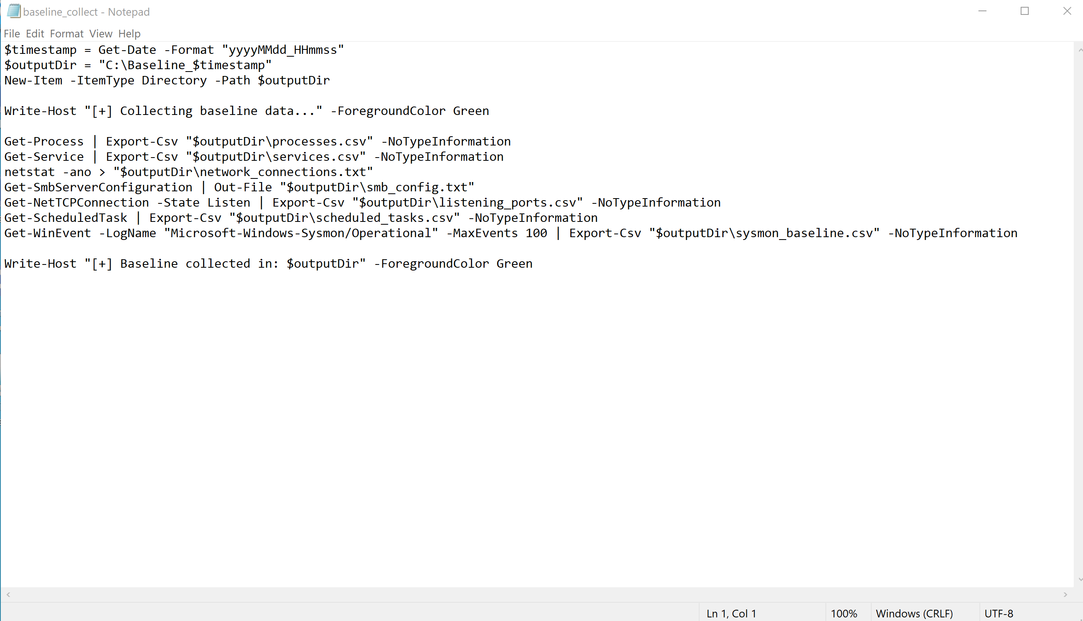
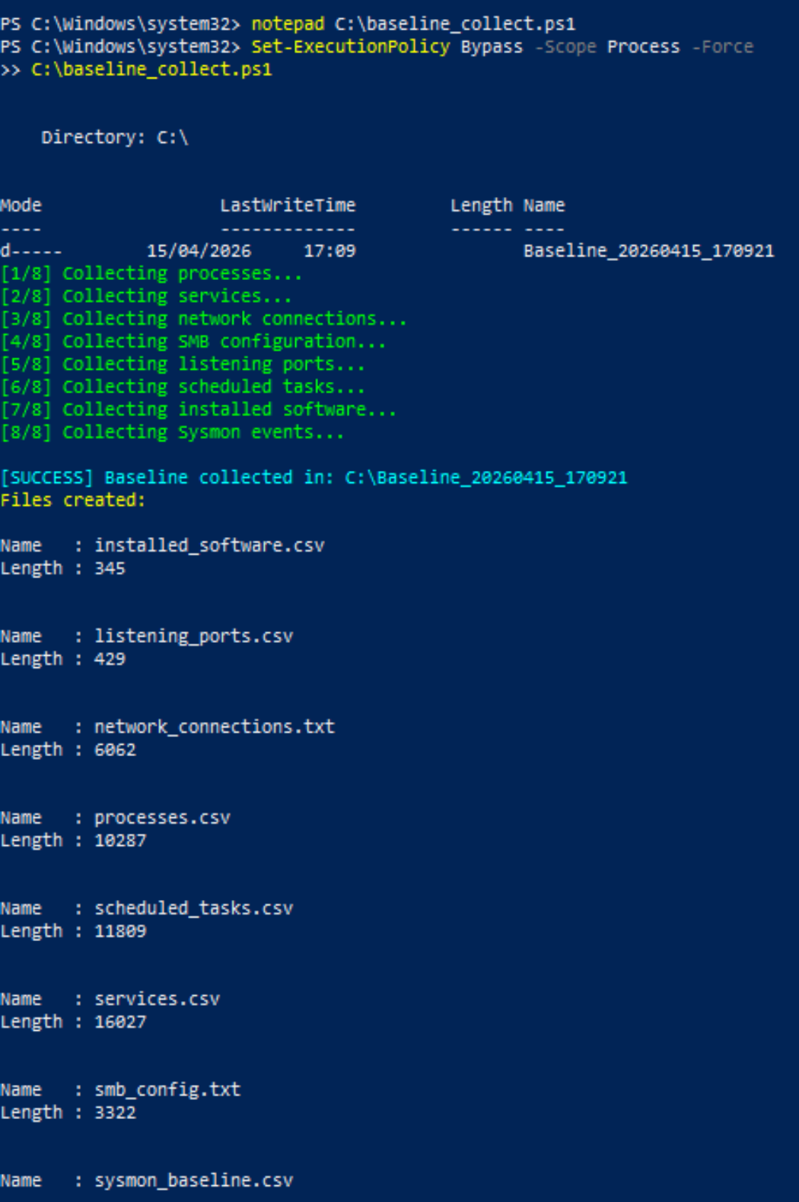

Appendix H: Baseline Comparisons
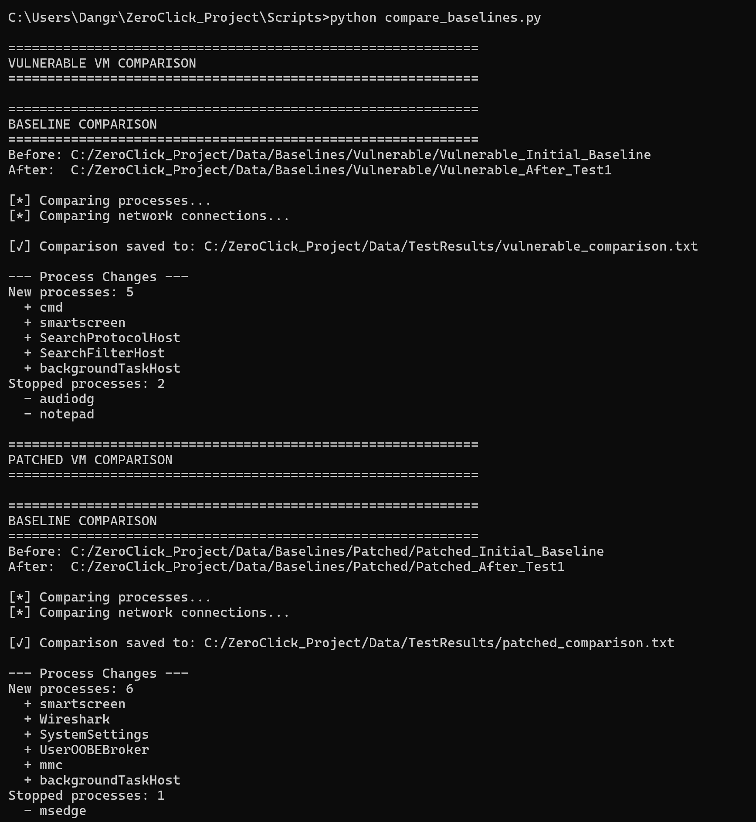

Appendix I: Ethics Approval Documentation
C:\Users\Dangr\OneDrive - De Montfort University\Final year project - P2789044\Project Contract - P2789044.docx

